Professional Dog Training Instructor

Module 2 – Canine Communication, Interpretation and Human Behaviour

Lesson 4 – Understanding Human to Dog Communication

Time to Speak Back!
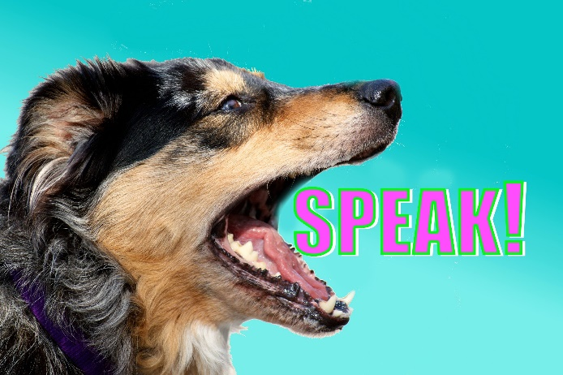
We have learned quite a bit now about dog to dog communication, and what different signals mean as a dog sends them to other dogs and people. Recent studies from around the world, UK to Brazil and Colorado to Finland have found that dogs have the ability to read human facial expressions and determine the humans emotional state from reading their communication. Anecdotally many trainers and those who work with dogs agree that using dog body language and directing those communications toward the dog will help to communicate to that dog the same message that it means when dogs deliver the message.

In other words – we can use dogs body language back to them to ‘speak dog’!

With dogs that are insecure, unsure or have been mistreated in the past often respond positively to humans who deliver appeasement signals, with loose body language. Yawning, lip licking, blinking and making eye contact before doing a head turn can help to reassure the dog that you are not a threat.
In the same way, frowning, staring, leaning forward and leaning over a dog can be challenging, intimidating behaviours to do which may either frighten or aggravate the dog.
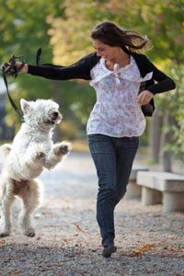
A 2001 study by Rooney and Bradshaw looked at human invitations to dogs to play to see which methods are most effective. The study found that initiating a chase game by either chasing the dog or running away from the dog was successful at initiating play in 100% of repetitions in the study. Humans bending over at the waist, and humans lunging forward toward the dog quickly were also both 100% successful in the study.
Inviting the dog to jump up on the human by patting the chest or other signal to jump up was successful 90% of the time, grabbing the paws 77% successful, play bows by the human 75% successful, grabbing the dog 67%, blowing air toward the dog 66%, pushing the dog away 62% and whispering or play talk were 56% and 55% successful.
Human play invitations that were unsuccessful include stroking the dog, pulling its tail, stamping feet, kissing the dog or barking at them.
A further study by Bekoff and Horowitz in 2007 went further to categorising how human-dog communication and play works well, and consider the following factors as important in successful play interactions.
- Clear indication of playful intent
- Eye contact and immediate response of the ‘receiver’ of the play invitation
- Mirroring the play behaviour of one another
- Good timing and balanced participation of both players.

The above studies show us that human-dog play can be very successful. However, there are some golden rules when interacting with dogs that should be adhered to. Pups will often begin to play with humans very similarly to how they would play with one another, and during play the human behaviour shapes the pup in to their adult dog play style.
Rules to follow with play revolve around ensuring that the play remains calm and controlled.
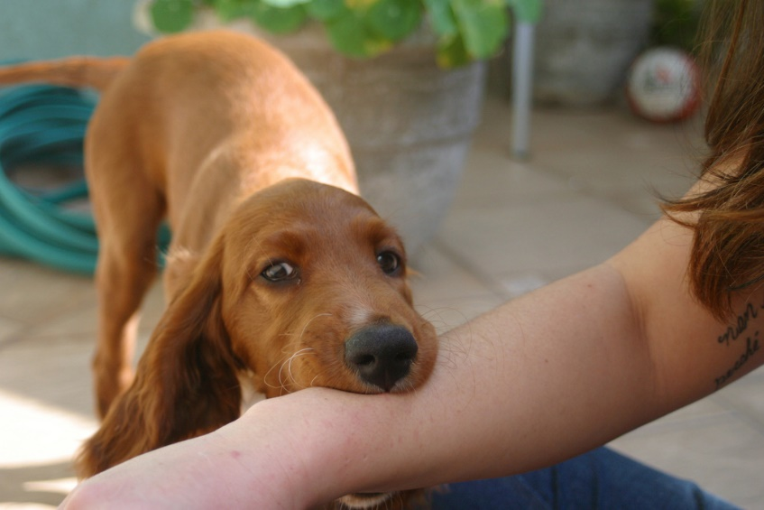
Mouths are not allowed on human skin. As soon as the pup opens their mouth and puts teeth on human skin, the play stops. This means you can freeze and become a statue until the dog rectifies their behaviour, then continue your play. If the mouthing hurts then the human should get up and walk away, stopping the play for a minute before returning. If the dog tries to play with mouths on skin a lot then to help the dog understand the difference between allowed play and not allowed play, in a high, happy tone, continue to praise the dog during ANY play that does not include mouth on skin, the instant the mouth is used say ‘ah-ah’ in a calm deep tone – quite different from the happy tone you had been using – then freeze or leave the play. When you return to playing, you should return to high, happy tone play.

Muzzle punching is not allowed during play. Dog-dog play usually revolves around play fighting, and a muzzle punch, where the dog ‘pokes’ their playmate with a closed mouth to evoke a reaction, is often seen. This is not appropriate human-dog play, and a similar response to mouthing should be done if a muzzle punch occurs.
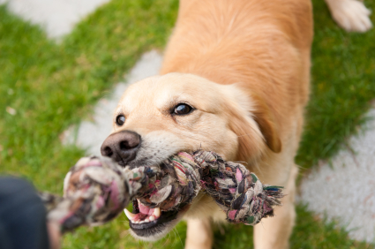
During object play all dogs should learn that giving up a toy to humans is a good thing to do. Not because holding on to the toy signifies power, dominance, or ‘winning’, but because there will be situations in the dog’s life where the human, adult or child, wants to take the object from the dog and this shouldn’t be a struggle. Dogs should be allowed keep hold of a toy after a game, but if asked to give it up they should be happy to.
During play ideally have two similar toys. As play starts to become more excited, leave go of the toy, and ask the dog to ‘drop’. Offer the second toy and make it super desirable by playing about with it. If the dog doesn’t drop the original toy, then walk away and end the play session. The game only continues if your dog is happy to drop the toy when asked. You can also try offer food to your dog when you ask them to drop (the dog will likely open its mouth and drop the toy to eat the food).
During human-dog play the dog should remain responsive to cues and human instruction. Interrupt play every 30 seconds by requesting the dog follow a simple cue such as sit, paw, down, or come to the handler when called. This will ensure that the dog is somewhat calm and can be controlled by the handler.
A dog’s ability to concentrate, train and learn increases significantly after a short play session, evident in the success of play as a reward for customs sniffer dogs, so play should be integrated in to training sessions.
Play is a fantastic way to improve quality of life, especially for older or unwell dogs, where lifting their mood is very important. Remember to play when strengthening the bond between human and dog, and should be prioritised between children and dogs too.
With shy dogs play can be initiated by the human laying on the floor, hiding their face, and calling the dog to them. They can also play hide and seek where the handler hides (initially in easy to find locations) and calls the dog excitedly.

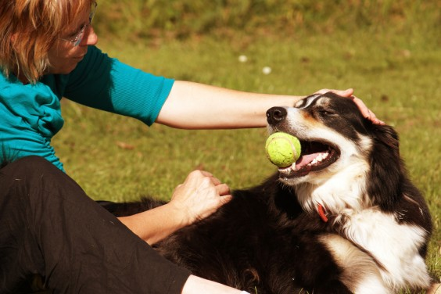

Communicating with Dogs – Consistency is the Key!
Using dog communication signals, encouraging (gently) play with the dog and then monitoring your own communication will all help to build a relationship with the dog. This information is all vital if you work with dogs. When people assume that some people are ‘gifted’ with dogs it can often be broken down to their ability to communicate clearly and interact appropriately with dogs.
Active bonding with the dog should be prioritised over inactive interactions. This means that if you are working with a client, or working with a dog, the plan should include two way activities where the dog and human are reading one another, reacting to one another and mirroring one another’s behaviour and signalling. In a world where the human-dog relationship can deteriorate to power walking around the block while the human wears headphones and looks at their phone, before sitting in the same room focusing on TV, we need to remember that the special relationship that dogs and humans have need to be worked on just like a human-human relationship.
Us human folk are tricky to read; we even struggle to understand one another and we are the same species! One of the best ways to build a dog’s confidence and trust in you as a human is to remain calm, clear and consistent in all communications with the dog. This is especially necessary in dogs that have been mistreated or abused in the past.
Calm is important. No good decisions are made in heightened emotional states. Often owners become frustrated, this alters their body language and tone of voice, which in turn confuses the dog. The owner assumes the dog is becoming disobedient and becomes more frustrated and cross, while the dog often becomes fearful and distressed as they try to understand what the owner wants. In such situations, it often emerges that the dog doesn’t fully understand what the human wants from the beginning, and as the owner becomes more frustrated they are no longer giving the cue that they think they are.
Often if you ask your dog to ‘sit’ you are standing in front of them with a treat in your hand. This is the ‘snapshot’ that the dog takes in and the dog learns that this is the cue that means ‘bum on floor’. As the owner becomes frustrated their tone of voice changes, their facial expression changes and their body language changes so the cue you think you are giving, and what the dog sees, are not the same thing.
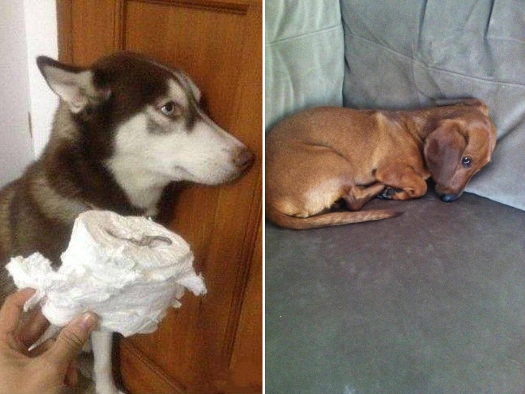
Another problem with the lack of calmness is that it is detrimental for the human-dog relationship. ‘Funny’ videos that circulate regularly through social media where dogs appear to look guilty are in fact dogs that are afraid that their owner is going to hurt them. Dogs will only learn to associate a behaviour and its consequence if they occur within two seconds of each other. So, if a dog begins to rip up a book and within 2 seconds the owner gives out then it is possible that the dog will know the owner is cross because the dog ripped the book. However, like in the many YouTube videos, if a dog rips up a book and an hour later the human returns from work and begins to speak sternly to the dog and the dog appears to look guilty then in this case the dog has simply learned that at times the humans are scary and mean.
The response of the dog to the human’s random emotional outbursts will depend on the dog, and the dogs learned history. Some dogs will freeze and attempt to be invisible, some will flirt and attempt to diffuse the situation, and some may challenge the person.
Clear instructions should be given to dogs by the handler always. To do this it is important that the dog is actually listening to the handler before the instruction is given. A dog’s name can be considered our way to say ‘listen to what I want to tell you’. It is fine to call the dog’s name several times to ensure that they are focusing on the handler before a request is given to the dog. Should you want to dog to sit, you cannot expect them to listen and respond if they are busy sniffing a rabbit hole. Instead, first call the dog’s name. Once they look to the handler then they can request ‘sit’. It’s important that the request is a very clear cue. Siiiit, sitdown, sitsitsit, Sitttah, and sit are five different cues! Remember this when communicating with dogs. Your cue should be clear. The dog should be listening. You should give the cue at a similar tone, pitch, volume and pattern so that you help the dog to fully understand what you are asking of them. Again, remember to give clear body language too. If you use hand signals don’t be surprised if the dog doesn’t follow the verbal cue without the hand signal. If you have only trained your dog while you are standing don’t be surprised if the dog doesn’t understand you when requesting a sit as you are sitting on the couch.
Clear communication will help to set the dog up for success.
Finally, be consistent. If you ask for the behaviour, and you are confident that the dog heard you and fully understands the cue, then wait for the behaviour. If you ask the dog to sit you should get a sit. Of course, never use fear or force to get the dog to sit but if they do not respond to the verbal cue you can try to prompt the dog to sit by luring the treat over their head, pretend you have more goodies in your pocket, and wait for the dog to give the sit before praising. If the dog learns that its quicker, and more rewarding to respond to human requests immediately then you are likely to have a happier, more obedient pet.
Rules should be consistent. If the dog is only allowed on the couch when the owner is particularly affectionate then gets told off for getting on the couch another day this can be extremely distressing for the dog – more distressing if never allowed on the couch. This should be explained to children or anyone who encourages rule breaking!
A responsible owner should encourage others who care for their pet to also communicate calmly, clearly and consistently with their dog.

Communicating Polite Greetings
When working with a nervous dog it is important to remember that human presence can be overwhelming. Greeting that dog should be done correctly as far too many people greet dogs incorrectly.
Firstly – staring at a dog directly, facing the dog can be slightly intimidating both to nervous dogs and to nervous people. When greeting dogs always stand sideways.
Secondly – dogs are small! Standing tall, or even worse, leaning over a dog, can be intimidating and is also a challenging dog-dog behaviour. When greeting new dogs crouch down by your knees with your back straight so that you don’t appear to be bending over the dog.
Thirdly, and most importantly, remember personal space. People often approach dogs, and occasionally corner them, to greet them. The correct way to greet a dog is to bend down sideways at a DISTANCE from the dog, and call them to approach you. This will show you whether or not the dog wants to interact. If the dog does not approach it does not want to interact and that should be respected.
Fourthly, if the dog does decide to approach keep your hand outstretched and held low. This will allow the dog to sniff if they approach so they can figure out a little more about you, and it also means that if the dog does approach having your hand low will encourage you to touch the dog low. This means scratching the dog on the chest or under the chin. It is incorrect to reach over a dog’s head and pet it on its head despite this being the ‘go to’ when greeting dogs. Most animals will respond with at least a slight fearful response when another animal reaches over them – even humans feel uncomfortable on a plane when others lean over you to reach the baggage compartment, and I am yet to meet a child that likes being patted on the head! You should never reach over a dog’s head in greetings. Instead, from your bent down position, start off with a scratch on the chest and under the chin. You can then continue the scratching up behind the ears and over the neck to the head but the point is that the dog is prepared and enjoying the interaction before you get to the dog’s head.
Finally, during the greeting, and especially with a timid dog, lend them your ear! As you are already bent down, sideways toward the do lead your ear toward the dog. Again, this avoids eye contact but it also encourages care behaviours. Mother dogs release pheromones both from mammary glands and, surprisingly, from their ears. Ear sniffing continues to be a behaviour that dogs love to do when finding out more about people so offering the dog your ear allows extra information sharing.

Five Second Rule
When humans do interact with dog’s awareness of the five second rule is beneficial.
The five second rule revolves around petting a dog for five seconds before stopping. This allows the dog to show the human whether they want to continue the interaction. The dog will either remain unresponsive, or even move away, when the interaction stops after five seconds. If the dog was enjoying the interaction then they will let the human know by nudging, pawing or rubbing against the human to continue the interaction and petting. If this occurs the dog has communicated that they enjoy the interaction and want more.

Treat and Retreat
If the dog is too nervous to approach, then try the treat and retreat method. Begin out of sight from the dog. Approach to a distance that the dog is aware that you are present but doesn’t attempt to move further away.
Toss the dog a piece of extremely high value food such as warm sausage or chicken.
Then walk out of sight for a few moments until the dog eats the item you tossed.
Repeat, remaining at a large distance, and go out of sight between each interaction.
You can gradually approach at a slightly lesser distance when you toss the food item but read the dogs body language for any other stress signalling.
This treat and retreat method is a fantastic way to help the dog to learn that good things happen when a stranger approaches and bad things happen (food goes away) when the human disappears. Ensuring that the human disappears will allow the dog to calm and have a breather between repetitions and will also result in the person reappearing becoming a predictor of good things.
Can You Reinforce Fear?
Many sources of information will tell you that if you comfort a fearful dog you are going to ‘reward the fear’ and make it more likely that the dog will behave fearfully in the future. However, this is wrong. Fear is an emotional response to a frightening thing, so ignoring the dog and assuming this will help is incorrect. Soothing and comforting the dog while providing them with a sense of protection will help to elevate the suffering and fear that the dog is going through, in the same way as holding a friend’s hand through a trip to the dentist will help them feel less fearful. Acting fearful yourself, such as using I high pitched panicked tone may make the dog feel more anxious as ‘even my owner is afraid’, but calmly talking to the dog, attempting to distract them with play or training if possible, or calmly stroking with gentle praise can help to provide a sense of safety to the dog.

Leave me Alone!
We can use the dog’s own communication to communicate back – especially when they are bothering us
When dog’s attention seeks, we can respond by using head turns and averted eye contact. To use this to send a message to the dog then your timing needs to be spot on. The instant the dog begins attention seeking behaviours the human should immediately respond with a head turn and averted eye contact ‘I am not interacting with you’, then once the dog stops attention seeking then the human can focus on the dog again saying ‘I will interact with you when you are calm!’.
In Closing
The ability to communicate efficiently with dogs, and interpret dog’s communication correctly, will require practice. Studying all the modules will help you to learn the correct terminology to the different types of signalling but to truly become ‘fluent’ in speaking dog you will need to practice, just like learning a new verbal language. Watch your own dogs, watch videos on YouTube. Videos of dog parks are very educational. Get out to your local park. Listen to dogs, they have so much to tell you!

