Introduction to Professional Dog Care

Module 3 – Introduction to Understanding Dog Body Language

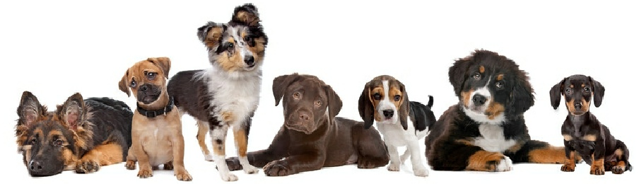
Introduction
Our dogs are constantly speaking to us, but unfortunately we do not know how to listen. Our deafness to dogs’ communication can often leave dogs feeling frustrated and needing to protect themselves when cries for help are ignored.
Dog body language has so much to it that it could go on the leaving certificate curriculum. This introductory module will look at dog body language that precedes aggression as this knowledge will help you to learn how to predict and, more importantly, avoid aggression from dogs. Videos, images and explanations in video format along with further informative manuals will be included, as well as video interpretation assessments.
Should you carry on your studies here at Creedons, many of our professional courses include additional training on understanding body language, such as interpreting appropriate play, understanding and adjusting your own body language, interpreting and understanding predatory behaviour, understanding when dogs are likely to attack for ‘fun’, interpreting and understanding dog-dog fights and more, so if you do intend to work professionally with dogs we strongly recommend you continue studying at Creedons so you can fully understand how to interpret dog behaviour.

Did you know, much of the body language that dogs use when expressing themselves subconsciously is actually identical to body language that we humans use to express the same emotions?

What is Body Language?

Body language is a way to convey your inner emotional state. Body language in dogs also represents behaviour, so the dog’s behaviour also conveys its inner emotional state.
While in humans there are many courses and mechanisms that you can learn which will allow you to consciously alter your body language to hide the way you’re feeling, dogs often simply express what they are feeling there and then without the forethought to alter their behaviour to deceive and hide their emotions.

Many of the subtle body language movements that dogs use are conscious movements, while others are involuntary. Often involuntary signals are mistaken for the dog expressing itself though these changes are physiological and are not under the control of the animal.

Emotional States in Dogs
There are many who argue about dogs, emotions, and what dogs think and feel. The scientific world, until very recently, believed that animals did not feel emotions, including pain, and that they simply responded to stimuli in the same way that a tree splits around electric cables, simply as a reaction. In fact, many scientists still believe that animals don’t feel pain and it is not unheard of for vets to perform surgery on animals who are not sedated. The generally accepted consensus among neuroscientists working with human and/or non-human subjects is that only humans are conscious - have the ability to experience internal, personal subjective experiences.
What are emotions? What is sadness? What is happiness? How do you know that you are happy? How do you know that others are happy? Quite often in human emotions we understand what emotions are by simply verbalising what we are feeling internally. We cannot pin point what anger is, except to explain what it feels like to be angry. We understand when others verbalise that they are feeling sad because we also recognise that feeling from being in such a state ourselves.
While we often say that we know someone is sad because they have their head hung low, avoid interaction, have tears in their eyes and so on, these are behaviours very much under the control of the individual, so while we may watch an actor crying on a screen we understand that they may not have been emotionally experiencing sadness at the moment of recording. A ‘psychopath’ is often defined as someone who does not have a conscience, and that does not feel emotions. However, psychopaths can very easily pass for a ‘normal’ person by mimicking the body language of a person in an emotional state, so in effect, emotions are the internal ‘feeling’ that we have and not the external body language.
Of course, we have dogs that are trained to carry out behaviours that we believe express their emotional state. A dog in a film can be trained to lift its lips expressing its teeth in a behaviour that is often interpreted as anger, though this dog’s internal state may be one of joy as it is anticipating a treat, or fear, as it may have been trained using the addition of punishment. In reality, dogs often express such behaviours at the same time that we could logically assume that they are feeling an emotion.
Many of us pet owners of course disagree with neuroscientists who believe that dogs don’t have a conscious, and we strongly believe that our dog has a wide range of emotions, though in the past we were dismissed as anthropomorphising our animals.
Anthropomorphising means putting human emotions on non-human objects or animals. Often people believe that some objects (below) appear to be ‘mean’ or believe that their dog is ‘sulking’ for getting in trouble when these are very much human emotions.

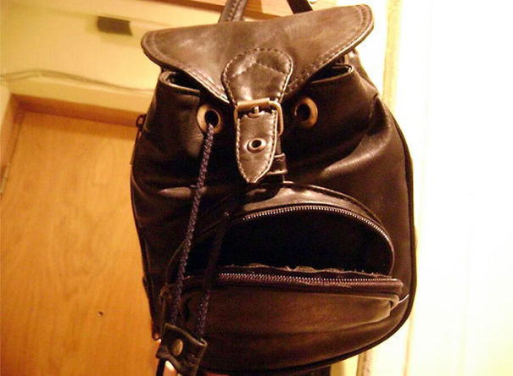
Anthropomorphising at its best!
The pioneering scientist to change the way science looks at non-human consciousness was Dr. Jaak Panksepp, who still today researches animal consciousness. He carried out many experiments – some of which you may have a hard time stomaching – and found out that without the ‘new’ brain, many animals behaved in a manner that would be typical of how they potentially could act if they were void of emotions, and when they animal had the ‘new’ brain intact their behaviour indicated that their choices were influenced by emotions.
Dr. Panksepp began exploring the brain of mammalian brains and their functionality in comparison to that of the human brain. Without overcomplicating it at this level, in basic terms he found that the non-human brain would function very similarly as human brains in response to stimuli that caused humans emotions.
Panksepp’s work has led him to conclude that basic emotion emerges not from the cerebral cortex, associated with complex thought in humans, but from deep, ancient brain structures, including the amygdala and the hypothalamus.
So an animal expressing behaviours is likely to be doing so as a response to an emotion that the brain is feeling. When we, or animals, feel emotions, different things happen to the neurochemicals in our brain, for instance, some are depleted while some increase in production.

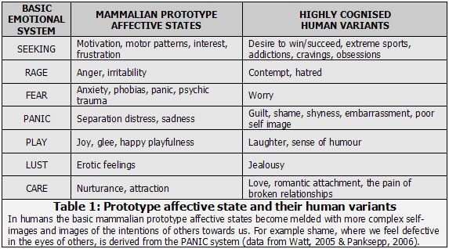

Seeking
Seeking emotion can trigger several behaviours, often the animal seeking a release of feel good hormones. A dog chasing its tail is often seeking the release of dopamine, a calming, pleasant emotion. A dog seeking its ball is again seeking the release of adrenaline and dopamine, the desire for people to bungee-jump could be put down to their seeking of a rush of adrenaline and dopamine. Seeking behaviours in dog behaviour are often seen in repetitive behaviours, such as over grooming, seeking an escape, seeking the company of others and so on, carried out for the desire to receive an increase in dopamine in the brain.

Stimulus is a word often used in biology — something that causes a reaction in an organ or cell, for example. In behaviour it is also anything that causes a reaction. Hunger could be the stimulus for going to the fridge, a phone ringing could be the stimulus for answering the phone, a smell of another dog’s pee could be the stimulus for a dog to pee.

Fear
Fear is essential for survival. When a stimulus is taken in, whether the animal sees something, hears something, smells something etc., the information will go into the cerebral cortex of the brain, where thinking occurs, and will then, if a stimulus that should be feared, trigger the amygdala. If the animal is exposed again to the stimulus, and has already learned to fear the stimulus, it can trigger the amygdala immediately and skip the cerebral cortex. This means that once an animal learns to fear something, future exposures can skip the animal’s time spent thinking, and instead shoot straight to simply reacting. Fear is responsible for so many behaviour problems in dogs as often the owner finds it difficult to expose the animal to the stimulus where the animal still ‘thinks’.

Rage
Rage is often undervalued in dog behaviour, often dismissed for a fear response, yet rage is a recognised behaviour in animals. It can be initially derived from fear and when constant exposure to a fearful stimulus prolongs a dog may show rage triggered behaviours. Teenage dogs often show rage behaviours when they become frustrated.
Barking at neighbours, or through windows often stem from rage.

Lust
Often relating to reproduction, dogs attempting to find a mate, and in intact animals this emotion can be responsible for a lot of behaviours.

Care
A female dog with pups will express a lot of care related behaviours driven from the care emotion to look after the pups. Phantom pregnancies in dogs often result in a lot of behaviours triggered from the care system. In dogs it is only really seen in females, when their brain neurochemistry changes to include a lot more care related hormones.

Panic
Panic occurs a lot in behaviour problems, and none is more evident than separation related disorders (previously separation anxiety). Separation related behaviours such as whimpering in young pups can be described as a similar response to a human feeling grief. Physical pain and emotional pain share very similar neurological paths, so an animal in emotional pain is hurting to a similar level as an animal in physical pain. This knowledge often helps owners understand the importance of psychopharmalogical medication in animals with emotional pain. This pain is thought to occur to ensure that animals that live in groups remain in that group which is essential for survival.

Play
Play behaviours, while often mistaken for ‘practice’ behaviours (practicing hunting / fighting / reproducing etc.) are actually behaviours of their very own triggered by the brains play system. The play system is based on the release of opioids (natural endorphin) while seeking behaviours are based on the desire for the release of dopamine. So while seeking out prey or a mate may have similar behaviours expressed as play behaviours, this is simply because the animal has a small repertoire of behaviours that it knows, so play is by default based on behaviours the dog already knows.
The Ladder of Aggression
Back to behaviour.
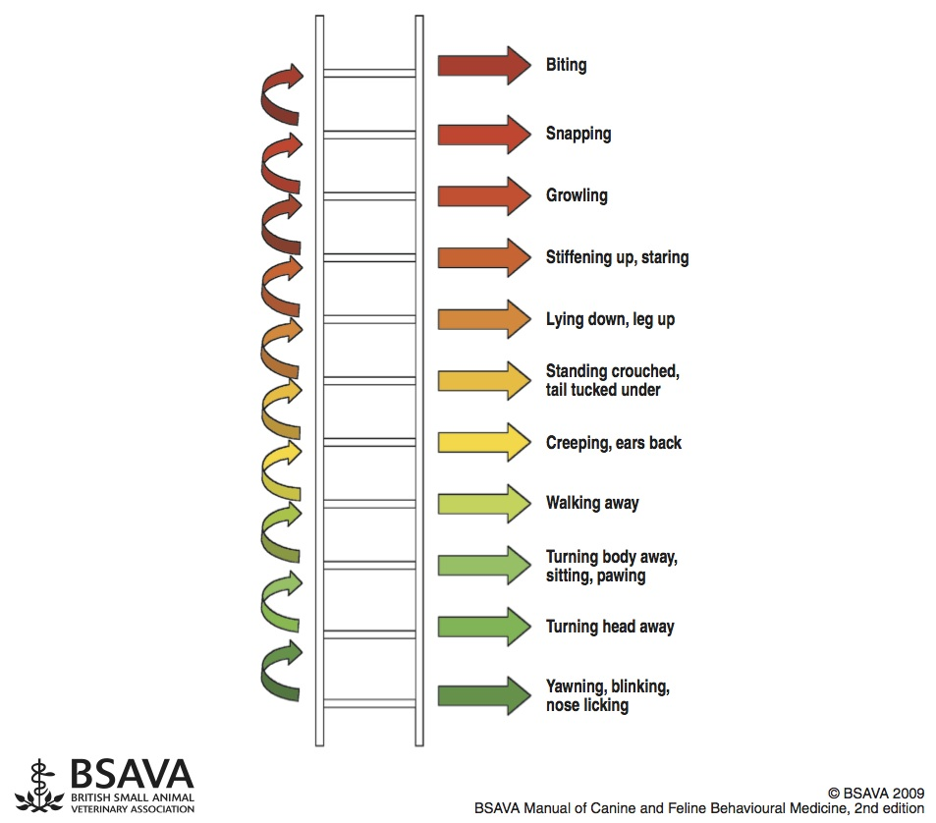
Now that we understand how important emotion is to the animal, and how it influences behaviour, we will have a look at behaviours that we see in dogs that are based on seeking, fear, panic and rage.

Ladder of Aggression
The ladder of aggression was designed by a fantastic veterinary behaviourist, Dr. Kendal Shepherd whose name you are likely to hear again and again if you pursue your career into the dog training and behaviour field.
The behaviours listed on the ladder are absolutely not exclusive or exhaustive, they are a sample and an example of how a dog will go from sleeping in its bed to biting a tormenting toddler.
The important thing to understand is that when you punish a behaviour, it decreases. So when you punish your dog for expressing a behaviour on the ladder of aggression it decreases.
When a behaviour on the ladder of aggression decreases it does not change that dogs dislike of something. So for example, if you punish your dog over and over again for growling at a toddler that is hassling the dog, then, yes, the growling should stop, but it won’t change the dogs dislike and fear of the toddler so the dog will potentially skip the growl and instead bite that child outright, which is a very dangerous situation, so punishing a dog for expressing a behaviour can be very dangerous as then we have less of an insight in to how that animal is feeling.
We can very much change how that dog feels around the toddler to stop the dog growling or biting, and that is addressed in our Professional Dog Behaviour Consultant course.
When you see an animal performing any of the below behaviours as a result to a stimulus, you remove the stimulus or remove the animal.

Displacement Behaviours
Displacement behaviours can also be considered seeking behaviours, as the animal is seeking to avoid an interaction with whatever is triggering the displacement behaviours.
Often the behaviours that we see in displacement behaviours can be considered as ‘I’m fine’ behaviours. We all know that when you ask someone if they are ok and they reply “I’m fine” then they are pretending and trying to act normal to cover up for hidden emotions. It is somewhat similar in dogs. Many of the maintenance behaviours that dogs do when they are genuinely fine are identical as behaviours that a dog will do when it’s not fine, possibly to show the threat that the dog is not worried to avoid an altercation. For example, in human terms, if you are walking down the street and see a potentially scary situation, such as people arguing, you are likely to pull out your phone and pretend you are ‘’totally fine’, or you may begin tugging at a thread on your coat, or whistling, basically in an attempt to show the scary thing “Oh, I didn’t even notice you”.
The key here is the phrase ‘out of context’ so keep that phrase in your memory and vocabulary when describing displacement behaviours.

Yawning
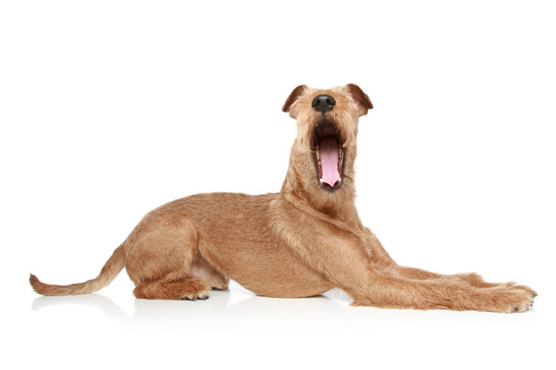
Yes, dogs yawn when they wake up and have a stretch. However, when they are in an uncomfortable situation, such as during grooming, or if you bring a stranger into the home, you may see yawning behaviour out of context. Often when you look closely it is like an ‘acting’ yawn, in so far as a deep intake of air is often missed.
Dogs are said to yawn in empathy when their human yawns. This may be possible, as you will see from the videos, or perhaps this is a natural yawn from being disturbed, though you will also footage of a dog yawning in a response to stress and frustration.
The internet is full of dogs yawning in a photography studio situation as often this is a strange and overwhelming environment for a dog, and many dogs are nervous of cameras.

Scratching
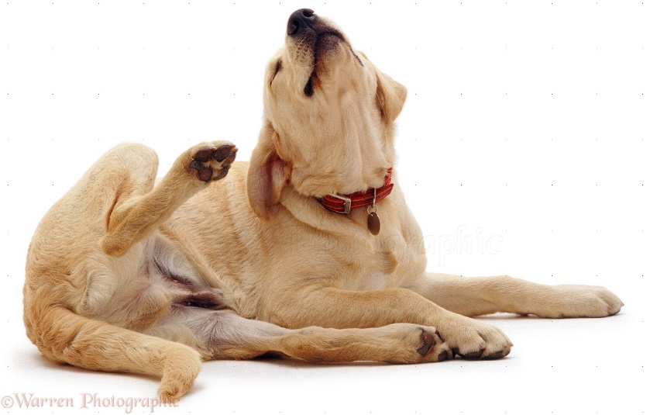
Of course, putting a new collar on a dog will result in a lot of scratching, or an animal with fleas or skin problems may be observed scratching a lot. However, a dog will often start scratching as a displacement behaviour in an uncomfortable situation. This scratching is often more intense than in a normal situation, or can come on rapidly like the animal has just had its hair tugged and needs to urgently scratch the area. It is often prolonged in comparison to normal scratching.

Sniffing
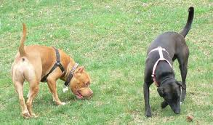
Sniffing can include sniffing the floor when there are other, more unusual things in the environment. It is similar to looking at the floor when others are arguing in an area. The dog is fascinated by a smell and seems oblivious to the other things in the environment.

Urogenital Check In

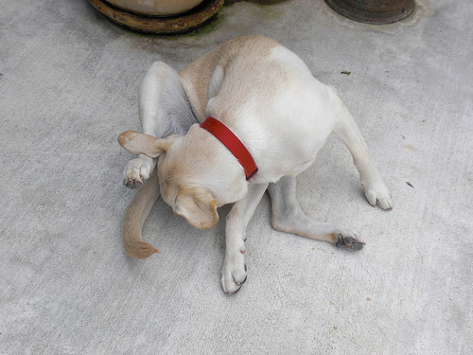
A urogenital check in is the term for when the animal focuses on their genitals, whether sniffing or licking. Obviously this can be part of normal maintenance behaviours, though in context, when something comes in to the environment and the animal responds with a urogenital check in, it may be attempting to avoid interacting with the stimulus.

Lip licking
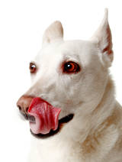
Take out a sandwich or a packet of crisps, and you will see lip licking. It is normal response to feeding or anticipation of food. However, in context, lip licking often occurs when an animal is uncomfortable. Again, this is a behaviour that humans do to, and when Cesar Millan was intensely interviewed in the past, he was seen performing lip licking behaviour in a response to the discomfort he was feeling.
Lip licking is very often missed when a dog is showing that it is uncomfortable, so now that you are aware of it you will notice it a lot more when the dog is unsure and uncomfortable.
Seeking Behaviours
Seeking behaviours in the Ladder of Aggression are quite often dogs that are seeking an escape from a stimulus. They may be seeking an escape route, or an escape from the interaction, or an escape through human assistance. Seeking behaviours in other situations can be seeking out food, pleasure, a mate and so on, but in this module we will only look at seeking behaviours that signal that the animal wants to get away from something, and if ignored may result in a bite.

Head Turn
The dog will turn its head away from whatever is causing it discomfort and the stimulus it wants to escape from. This is often thought of as a funny response to being ‘told off’ yet in reality it is an animal seeking escape from a stimulus it is afraid of.

Body Turn
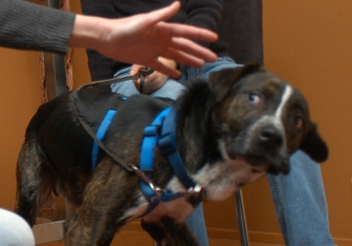
The dog will turn its entire body away from the stimulus that is upsetting it. This of course requires more energy and is more taxing than simply looking away from the stimulus, so an animal that moves its entire body away is serious about avoiding an interaction.

Slow Movement
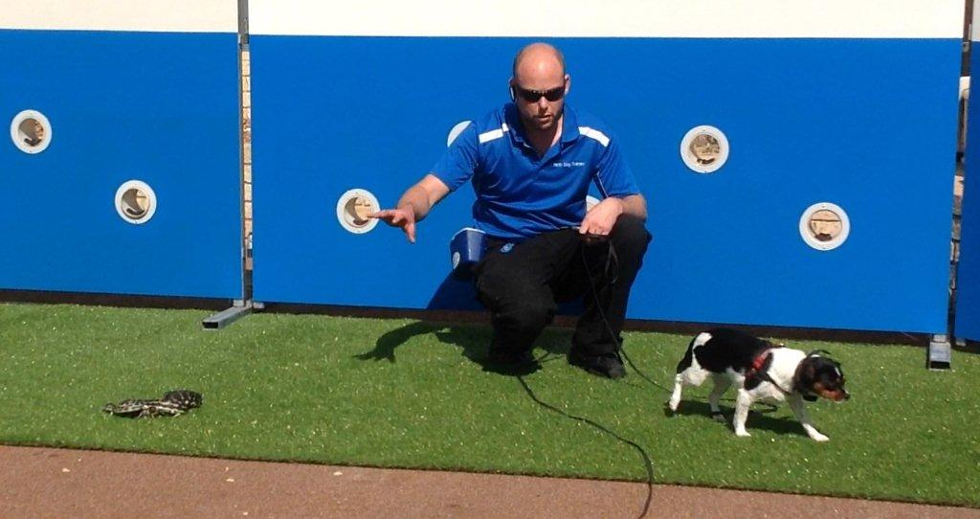
Often a dog will move away from a stimulus it is uncomfortable around or afraid of. Sometimes this movement is extremely slow as the dog does not want the fearful stimulus to notice it or to begin an interaction, or trigger the stimulus to pursue the dog.

Rapid Movement
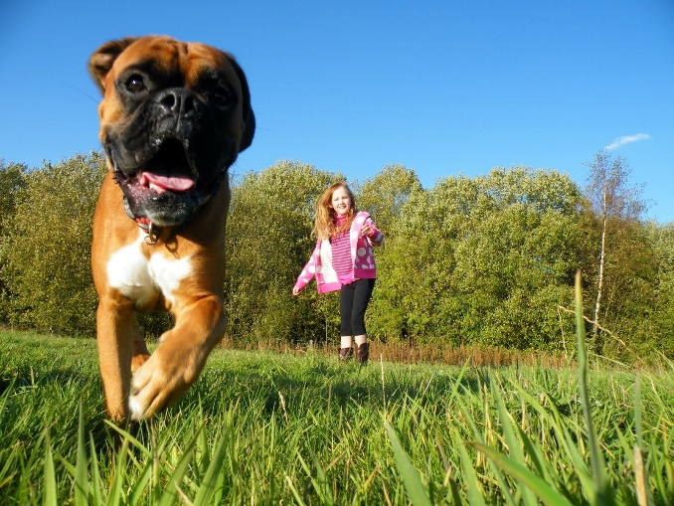
When the animal is trying to escape it will often run away from the stimulus. In extreme cases this can be triggered by the panic system, but when the animal is calmer it is often triggered by the seeking system.

Moon Crested Eyes
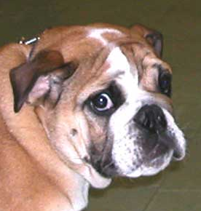
The whites of the eyes are often visible when the animal is seeking to see a route of escape, or when it is very much avoiding eye contact which we will look at again. The whites of the eyes are often, in context, a very obvious indicator that the animal is afraid.

Ears Back
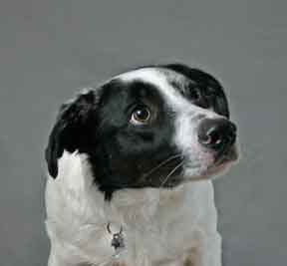
Dogs often turn their ears backward when they are in a situation they want to get away from, so ears backward are often a sign that a dog is afraid. It is considered to be done so that the animal can hear behind them to see if a threat is approaching or if an escape is an option.

Checking in with Owner
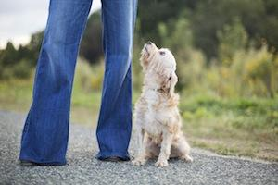
It is lovely to see a dog that responds to a frightening stimulus by checking in with owner, however the owner must then respond and help that animal escape from the frightening experience. The dog will often look rapidly from the ‘monster’ to the owner and back again so the looks are often flickers.

Fear Behaviours
While all of the behaviours in the Ladder of Aggression are considered as fear behaviours, we know from exploring emotions, that in reality these behaviours are triggered by different systems in the brain, and only a few of the behaviours on the ladder of aggression are stimulated from the fear system.
Describing all of the behaviours as fear driven is not uncommon, because they are all triggered by a stimulus that the animal dislikes or fears.

Paw lift
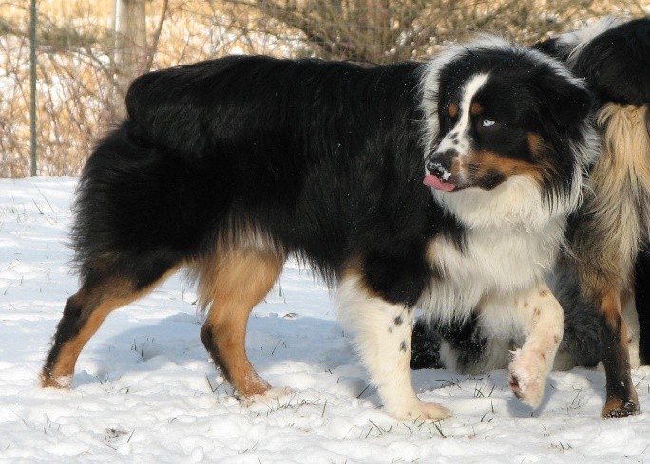
With this one, be careful to remember breed specific behaviours. Pointing breeds will often point when interested or alert to a stimulus, but not in a fear response.
A paw lift is when a dog lifts one of their paws off the ground, possibly in a manner to appear more vulnerable to avoid a challenge, or possibly as a side effect of the body moving away in seeking behaviours. Whatever the reason, it is a great indicator that, in context, the animal is unhappy and needs to be removed, or have the stimulus removed.

Furrowed Brows
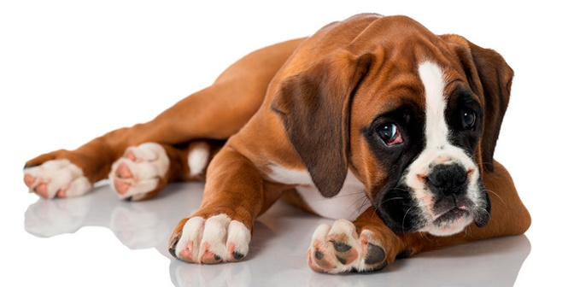
Furrowed brows are often that bit more obvious in your own dog or a familiar dog that you know what it looks like when it is nor fearful.
Often you will notice that similar to in a human frown, the dog will scrunch its face when afraid and there will be a lot of extra wrinkles around the eyes and the forehead.

Tense Facial Muscles
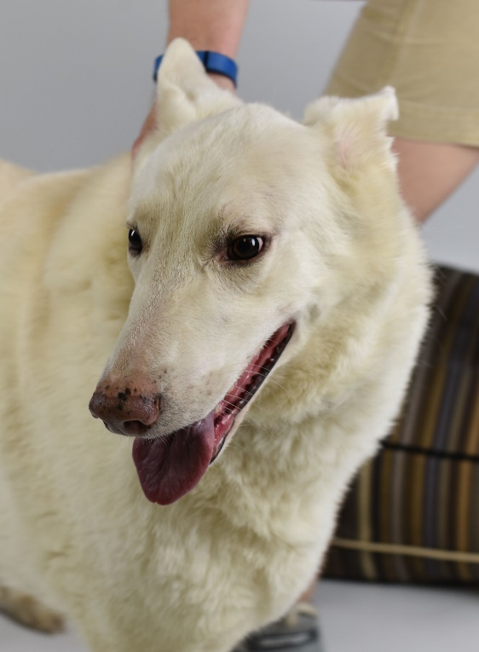
Again, like furrowed brows, tense facial muscles are more obvious in our own dogs. You can often see protruding veins and tendons, and often with tense facial muscles the whites of the eyes will also be visible as the facial muscles will be tight, pulling the skin back from the eyes.

Tap out
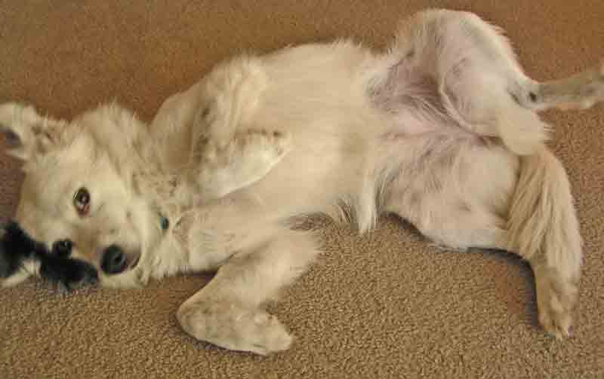
A tap out is very much misunderstood. If you go on YouTube and look up ‘guilty dogs’, you will see many, many videos where dogs are fearful and trying to tell the ‘monster’ not to hurt them yet people think it is a funny dog expressing guilt. These videos in fact show a dog that is scared of its owner, not an association that many dog owners would want if they fully understood that their dog does not remember ripping up the newspaper two hours earlier, but is instead looking at its owner as though the owner wants to harm the dog for no reason at all.
A tap out looks like a request for a belly rub, but instead the difference is the context, and often during a tap out the tail is still tucked covering its genital area. The animal is exposing its vulnerable area, its stomach, to show the monster that they will not retaliate, similar to throwing your wallet to a robber, or telling a thief in a raid “take everything you want”.

Hunched Body
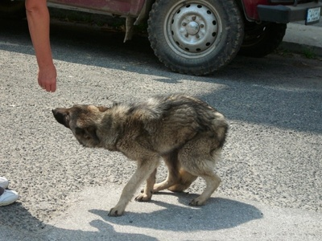
A fearful dog often hunches its body in to a curved shape, with its head tucked down. This is to make itself as small as possible to avoid being noticed, or also to protect its organs. While both a tap out and a hunched body show dogs that are afraid of attack, the different approaches depend on the dog’s personality and learned experiences. Often a tap out is seen in a dog that, when it was a pup, was rewarded with belly rubs for rolling over, so does it in a fearful situation in the hope that it will elicit a positive response from the human, whereas the hunched body is often seen in an animal that has been neglected so has not had enjoyable belly rubs, or an animal that has been abused and has experienced pain from the hands of a person before.

Tail tucked
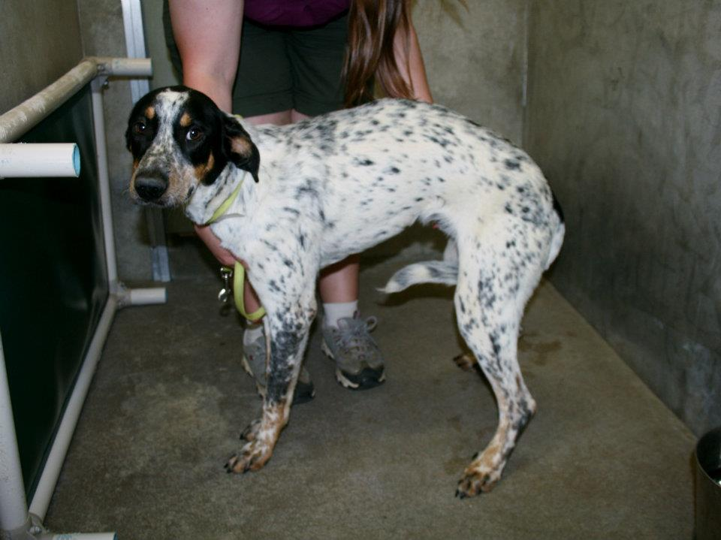
A tail tucked is a fearful response where the animal is protecting itself from interactions. It is believed to have originated as a response to other dogs when the dog does not want to interact, or be sniffed, and has carried through and evolved into a fearful response to situations where the dog is uncomfortable.
It is important professionally that you understand all of the different ways that different breeds hang their tails so that you understand when the animal is doing a tail tuck, or is just in its natural stance.

Avoiding Eye Contact
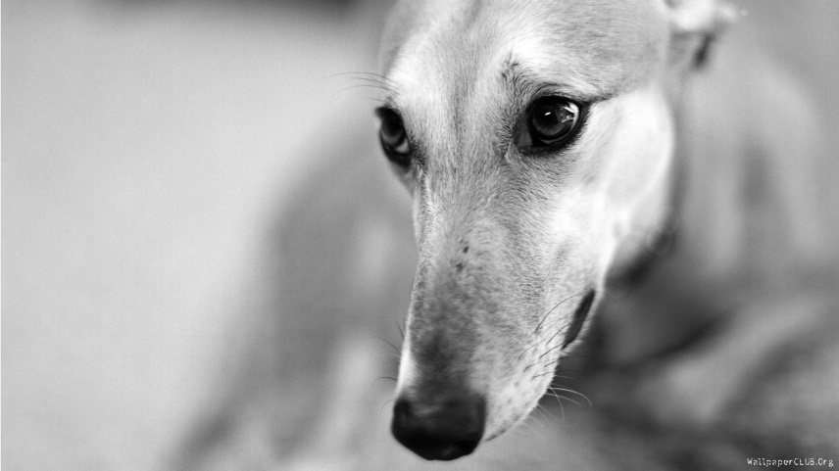
Avoiding eye contact can be a seeking behaviour, or a fearful behaviour when escape is not possible. The dog will make eye contact briefly then break eye contact quite quickly to show the other stimulus that it is not challenging them.

Panic Behaviours
Panic behaviours are quite often involuntary. When panic behaviours begin, the dogs physiological state has changed. When we are panicking, our bodies’ nervous system changes. Normally our body is in a parasympathetic nervous system state. What that means is that our body is functioning normally, blood supply is going to the organs and the body is carrying our basic maintenance, repairing damaged cells, assisting in nutrition and so on.
When the brain tells the body that it is an emergency, the sympathetic nervous system takes over and the priority for the body is to get blood supply to the muscles and to survive. This often results in a reduction in maintenance functioning of the body, and an increase in survival type functioning.

Piloerection
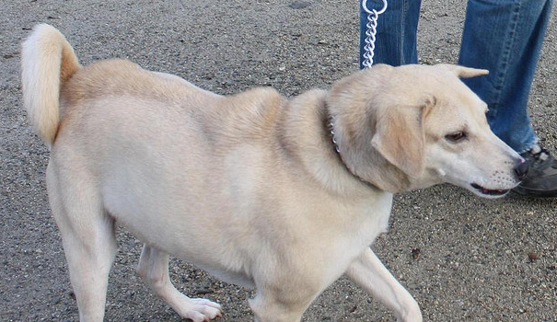
Piloerection is when the hair stands up on the dog. It does not mean aggression; it is a sign that the sympathetic nervous system has taken over. A dog whose hair is standing up needs to be removed from the situation as its body is entering panic state.

Panting
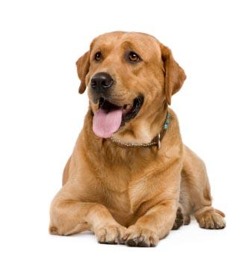
Panting is a response of the sympathetic nervous system when, in context, the animal begins panting in a situation where they have not been exercising nor are they overheating.

Dilated pupils
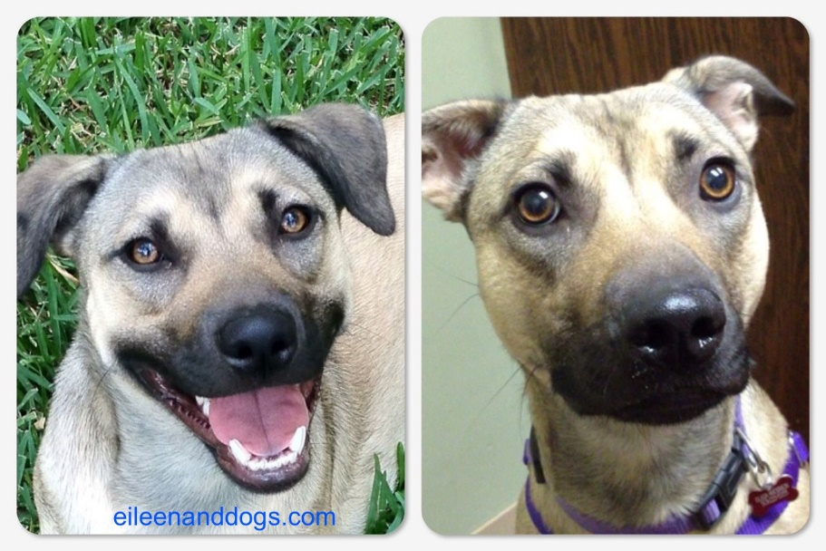
Dilated pupils are more obvious in your own dog, or a dog with blue eyes. They are a sign that the dogs body is panicking and the dog should be brought somewhere calm to settle.

Whimpering
Whimpering can be a learned attention seeking behaviour, but when the dog is beginning to panic they will often whimper uncontrollably, similar to a child crying when panicking or a person screaming. The dog should not be told off, but should instead be allowed to calm down.

Increased Heart Rate
This can be noticed by expert eyes, or by checking the dogs pulse (our Recognising Medical Abnormalities and Providing First Aid Care course will teach you how to check a dog’s pulse and how to recognise what is normal or abnormal).

Pacing
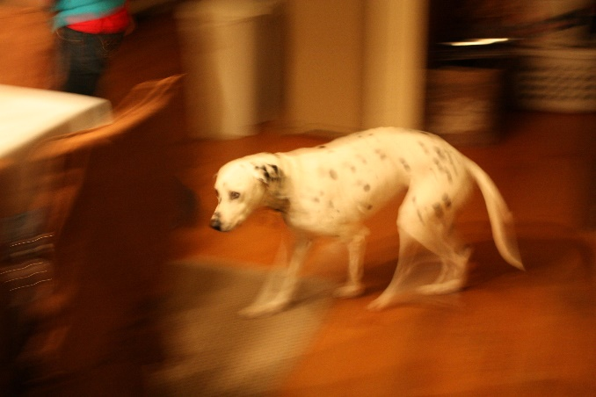
Pacing in a more frantic manner with no purpose is often seen when the dog begins to panic and is often seen in veterinary practices or with separation related disorders.

Freeze
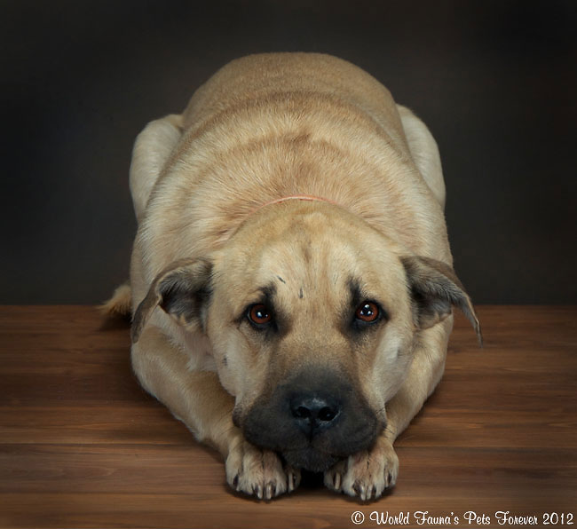
Depending on the dog’s personality and learned experiences, its response to a frightening stimulus will vary. The dog will often freeze in an attempt to go unseen from a frightening stimulus.

Fight
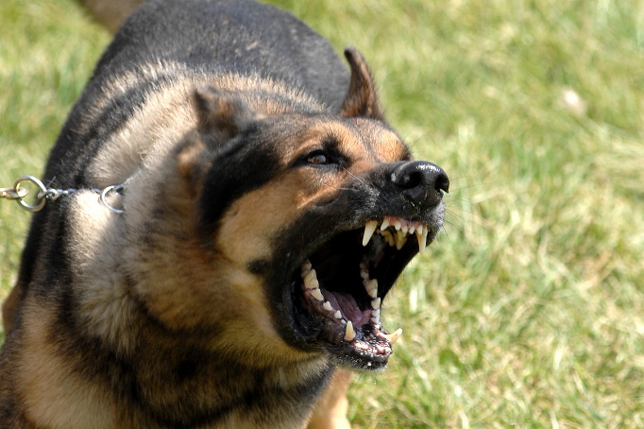
Fighting response to a panic very quickly flips in to the rage system so we will look at that next, though the panic system can cause the dog to then change in to the rage system quickly.

Flight
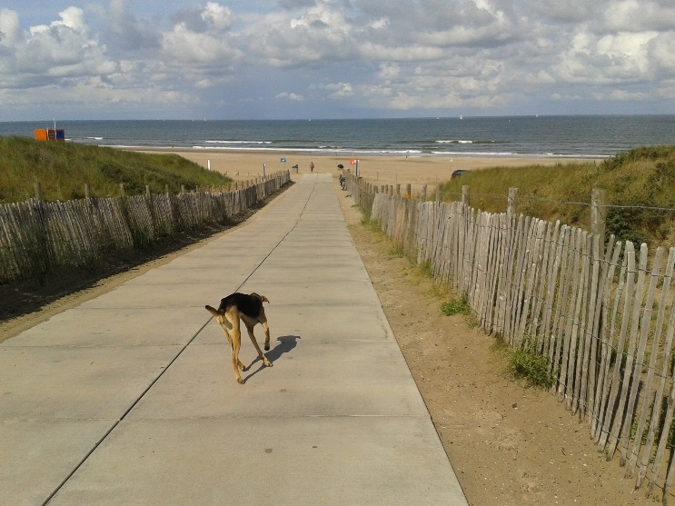
Again, similar to escape behaviours, and pacing when flight is not an option, as a response to a fearful stimulus, if the animals panic system is activated, the animal will flight. Often after a bad fright, or an experience such as being hit by a car, the dog’s panic system causes the dog to take flight and it will run and run until its body begins to recover and it calms down. Often this can result in many dogs going missing after escaping from a car crash.

Flirt
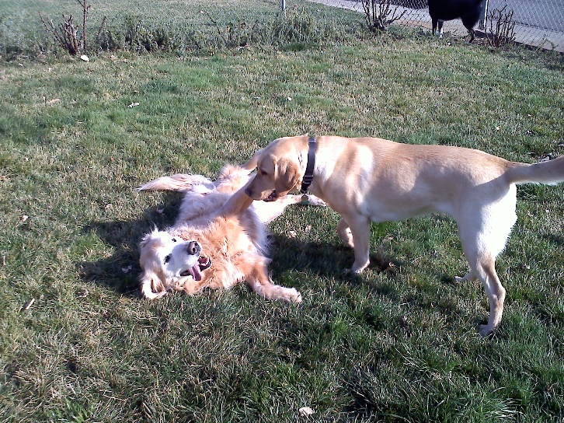
Flirt is seen similarly to some of the videos where the dog is ‘guilty’, the dog will respond to a frightening stimulus, when the panic system is activated, by doing ‘flirt’ behaviours where is basically reverts to acting like a puppy. You may see licking, tap outs, rapid body movements, twisting and wiggling like a pup.

Submissive urination
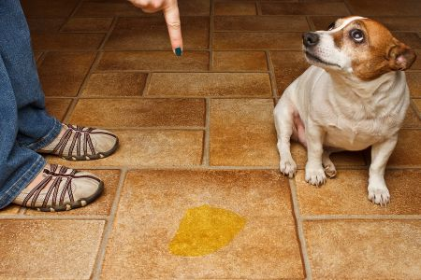
Another involuntary behaviour, this submissive urination can be seen when the dogs body is in a panic state for a good reason (think teenage girls meeting One Direction) or in a frightful panic state, the body is no longer prioritising digestion or focusing on the bladder muscles and submissive urination can occur.

Trembling
An involuntary behaviour. The body is responding to panic by triggering trembling.

Shake Off
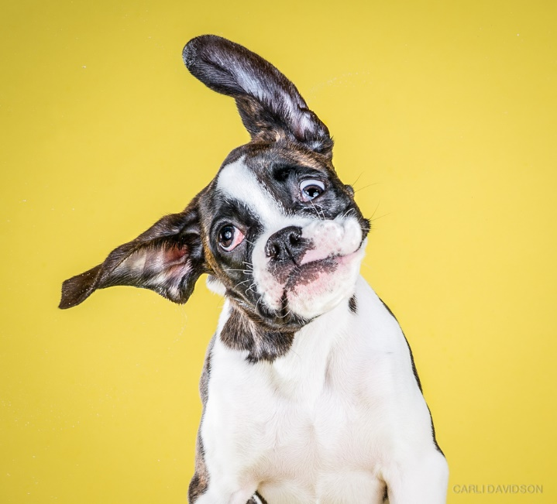
A shake off actually usually occurs AFTER the frightening experience but it is an excellent way for you to recognise that a dog is not comfortable with something.
The shake off can occur when your dog is wet, or trying to wake itself off, but in the ladder of aggression, a shake off is often seen when the body is leaving the sympathetic nervous system and attempting to return to the parasympathetic nervous system state and back to ‘normal’.
If an animal is seen trying to do a shake off but the frightening experience is not over, they will do a half shake, though usually if the experience is over they will do a full body shake.

Rage Behaviours
Rage behaviours often occur when an animal needs to survive. They also are involved in some predatory behaviours or in situations similar to anger – such as the animal has become frustrated and can no longer cope, or the animal is hurt during play and lashes out. Rage behaviours, while natural, are of course very dangerous in dogs, and when a dog is seen to perform rage behaviours a certified dog behaviour consultant should be seen urgently.

Hard Stare
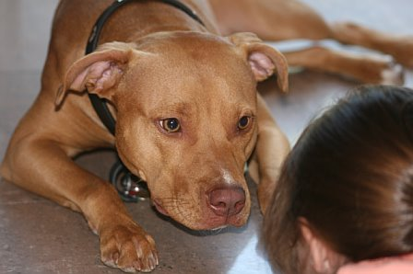

A dog that is in a rage state will often stare at the stimulus that they are challenging. This often is a pre-cursor to a fight and the dog is stimulated to start the challenge repertoire of behaviours by the rage system in the brain.
The dog will make eye contact and hold it. This is often seen too in predatory behaviours where the dog will stare at its prey.

Lower head with Eye Contact
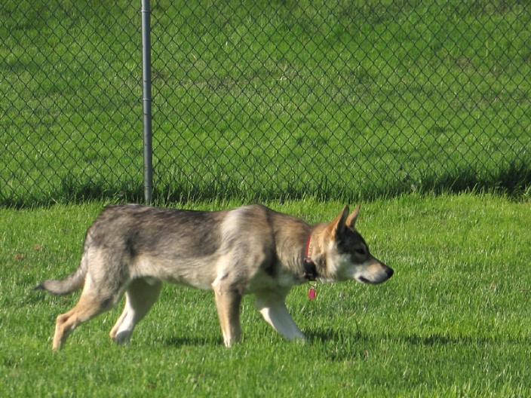
This is often seen in dogs that are about to attack, whether for predatory, hunting reasons, or to challenge another animal. The head will lower between the shoulders but instead of tucking the head to direct it downward toward the paws, a dog driven by the rage system will keep the lowered head pointing forward.

Lip Curl
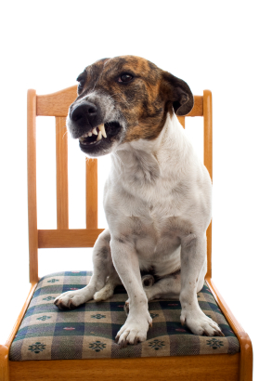
Despite the many many, many behaviours that we have already looked at in this manual, often the lip curl is the very first behaviour that people notice! The lip curl is triggered by the rage system and allows the dog to show its teeth toward the stimulus that it is threatening with an attack. It is similar to holding your fist toward another person, threatening them that they better stop what they are doing or else an attack will follow.
There are offensive and defensive lip curls. Technically we can consider a defensive lip curl a seeking behaviour as the dog is seeking an escape from the threat, though in reality it is triggered by the rage system. The offensive lip curl is where the lips are forward like a pucker and the defensive lip curl is where the lips are pulled back like a wide grin.

Growl
A growl is a vocalisation of a warning. Growls often start of low and quiet and escalate when not responded to appropriately.

Bark
A bark can often be a warning that the dog has had enough.

Air Snap
Some dogs will, luckily, do an air snap before an actual bite. An air snap is often thought of as a bite attempt which the person escaped from, but in reality dogs can move much faster than us and it can be thought that in many cases the dog was giving a final warning before a real bite.

Bite
There are many different types of bites, and Dr. Ian Dunbar’s chart below will help you to understand that a bite is relative to the size of the dog, and a bite is not just a straight forward thing, there are many different types, and levels, of bites.

