Practical Dog Management
Unit 6 Communication Skills
Dog to Dog Communication

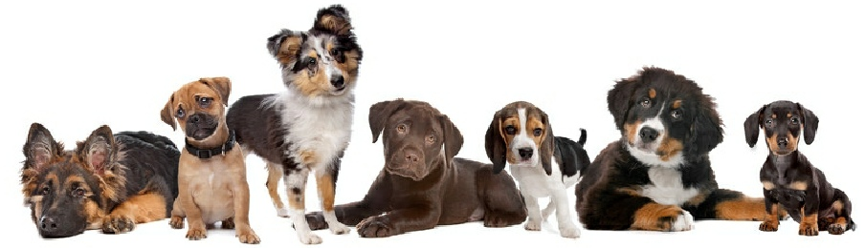

Dog Play, What Is It?

We can all visualise play, and have different ways to explain what play is, but to analyse play from a scientific viewpoint can be difficult.

In the scientific world, the most widely accepted definition of play was penned by Bekoff and Byers, in 1981. They suggested that play is “all motor activity performed postnatally that appears to be purposeless, in which motor patterns from other contexts may often be used in modified forms and altered temporal sequencing”. However, appearing purposeless underestimates the many benefits of play.
To be fully characterised as a play behaviour, the criteria determined by Burghardt, 2005), are that
- The behaviour is not fully functional
- The behaviour is spontaneous, voluntary, pleasurable or autotelic (done for its one sake)
- The behaviour differs from serious behaviour in terms of its function, duration and / or frequency
- The behaviour is repeatedly performed but not stereotyped (OCD)
- The behaviour occurs when the animal is healthy and free from stress

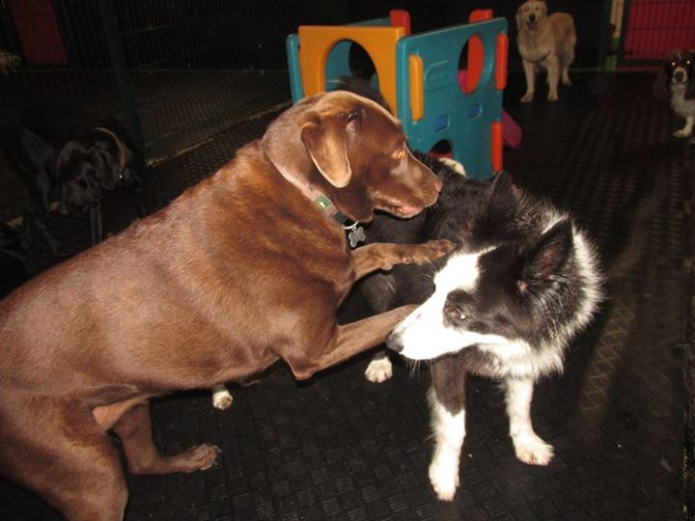
Why Do Dogs Play?
We know that play has many benefits to dogs. It releases surplus energy. The domestic dog is no longer a working animal in the majority of cases. These animals have the ability to work long hours, which is no longer necessary. They also no longer need to hunt, protect themselves, nor survive cold and uncomfortable surroundings in many cases. This means that many dogs have surplus energy. Play provides a pleasurable outlet for such energy.
Play serves as an opportunity to create relationships between dogs, and figure out roles and tolerance between dogs. As new dogs begin interacting they learn what behaviours are acceptable and unacceptable between individuals, allowing for harmonious relationships to build. This is similar to new colleagues tentatively making jokes, or using somewhat rude language to determine what the other will tolerate. Dogs of similar play styles quickly learn that the other is a desirable companion, and this also occurs in people as they get to know one another.
Play also provides opportunity to practice survival based behaviours, such as mating, hunting and fighting. By playing using the skills necessary for survival based behaviours it means that when crucial events occur then the animal will be ‘fitter’, better able to respond appropriately. Again, people ‘play’ sports recreationally so that when it comes to a crucial, high pressure cup final, they will be able to carry out necessary behaviours.
N.B.
Play should NEVER occur when one or both dogs are restrained, on leash, or muzzled as this is not appropriate and does not allow for natural behaviours or expression of communication.

Social Behaviours
Dogs will carry out many different behaviours that are involved in social communication. Again, categorising behaviours makes analysis and interpretation of the dog’s emotional state somewhat clearer.
Social behaviours can be categorised into the following.
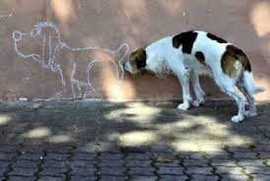
Ritualised Behaviours
These are common when dogs are trying to gain cooperation and compliance from another dog. Ritualised behaviours in dog-dog interactions include the ritualised greeting pattern where the dogs initially sniff the side of each other’s muzzle, followed by the neck, rear and genitals while moving in a circle behaviour.
Another ritualised behaviour in dog – dog communication is threat behaviour, such as lip curl, growl, pucker, bark and lunge.
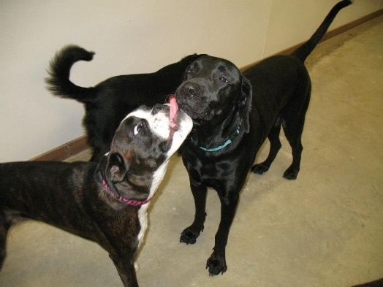
Appeasement Behaviours
We looked at appeasement behaviours in lesson 1. We can look at them further in this lesson as part of two-way dog-dog communication. Appeasement behaviours can also be called infantile behaviours, as the dog carries on behaviours that are more commonly seen in a pup when communicating. The dog may not behaviour in an infantile like manner at all time, but reverts to ‘wiggly worm’ to communicate to another dog.
This is thought to be a development that has progressed from the additional tolerance that pups get from adult dogs. A pup, in many cases, does not pose a threat to another dog so performing infantile behaviours, or appeasement behaviours, as an adult dog will communicate to the other dog that this dog is also not a threat. It often pacifies a potentially conflicting situation, and can be considered as showing ‘respect’ to the other dog.

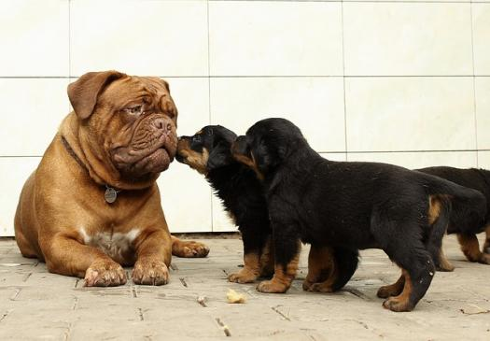
Confidence Behaviours
Current thought on dog behaviour strongly dismisses the dominance theory, including linear ranking in a social circle. We do not believe that the ‘top dog’ will boss around the others, nor will other dogs bow down at all times to other dogs.
Observing behaviour in a dog park or doggie daycare shows that there is no strict linear pattern of top dog to bottom ranking dog.
You will find a lot of literature where the author describes dogs as animals with ranking, or dominance, or status, or alpha and so on, and we strongly recommend that you critically analyse this information, check the date, the author, and if you still find the information credible, discuss it with your peers.
Dogs do however express behaviours that can be classified as confidence behaviours. This does not mean that this dog is ‘top dog’ or other dogs should fear this dog, it simply means this dog is ‘happy in its own skin’, is not fearful of other dogs, or fearful of a challenge.
A confident dog does not have the need to show appeasement behaviours during greetings – but may often be seen in play. A confident dog will not tolerate inappropriate or rude behaviours most of the time, and will quickly shut down another dog’s interactions by calmly applying correcting behaviours, though rarely escalating to a fight unless absolutely necessary.
A confident dog rarely enters a sympathetic nervous system dominant (fight or flight / panic) state, as they do not perceive others as a threat.
An insecure dog is often mistaken for a confident dog, as their involvement in challenges is misinterpreted as confidence, however the confident dog very rarely is involved in heated interactions, will walk away from situations where conflict may occur in a nonchalant, disinterested manner.

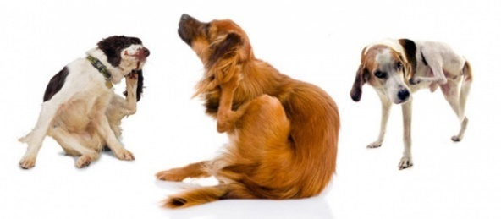
Displacement Behaviours
We looked at displacement behaviours excessively in lesson 1. They will often be seen in dog-dog interactions, and are very much respected in dog-dog communication, but almost always missed in dog-human communication.
The ability to recognise and respond to displacement behaviours will result in a lot of respect from the dog you are working with as they almost respond with ‘I don’t believe it; he speaks my language!’.

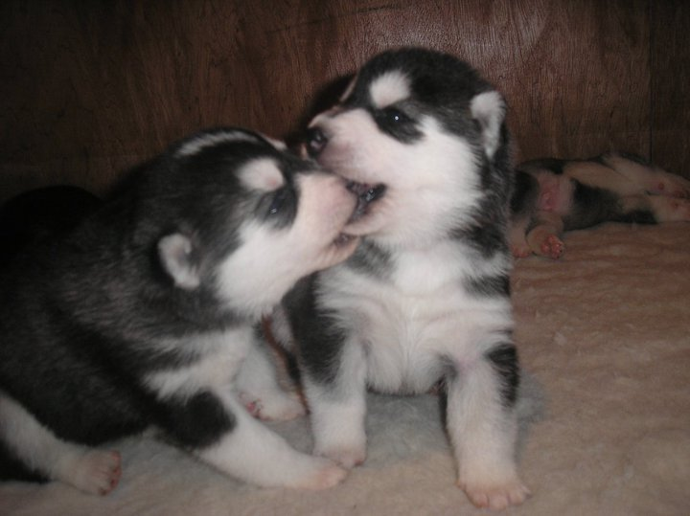
Correcting Behaviours
Correcting behaviours are used to communicate to another dog that their behaviour is inappropriate.
They are often punished by people as they misinterpret this communication as bold or aggressive behaviours while in reality they are very much essential parts of communication.
Here in Ireland we see many ‘rude’ or inappropriate behaviours from dogs during dog-dog interactions as they were not corrected while learning how to interact appropriately.
A dog observed performing a correcting behaviour, when warranted, should be praised and if the other dog does not listen, the other dog should be removed. Correcting behaviours in a social environment where dogs are mixing are vital to ensure the harmony of the group. They are part of communication and shouldn’t ever be punished.
Correcting behaviours are first seen in a mother dog with her pups. Inappropriate behaviour will be responded to with correction behaviours.
A muzzle grasp, where the mother (or any dog in later correcting behaviours) places their muzzle over the other dog’s muzzle, or head if the other dog is much smaller. They do not close their mouth, or cause the other dog pain, but simply hold them in place for a moment. The dog will sometimes do a half muzzle grasp where it opens its mouth wide toward the other dog without actually making contact.
A neck bite is seen where the dog does bite the rude dogs neck, but doesn’t inflict pain. The bite is often done in a ‘nibble’ manner.
A correcting bark, is seen when a dog is communicating to another that their behaviour is inappropriate. The dog initially turns its head away from the ‘rude’ dog, then barks and lunges toward the rude dog concurrently, barking quite close to the other dog. It usually then turns away again.
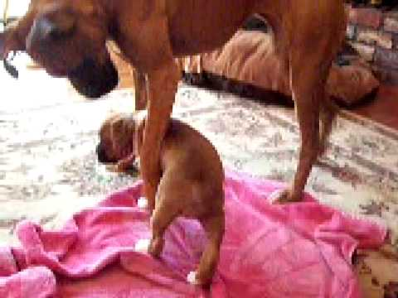
A correcting pinning behaviour is often seen with just one paw in larger dogs when the smaller, or puppy, is bothering them. They will place a paw over the smaller dog’s shoulders and pin them to the ground for a moment, in a body slam type movement.
In two adult dogs this will look more like a normal play pinning behaviour except the correcting dog will hold the rude dog for a moment too long, without biting or inflicting pain, simply holding the dog in place while using direct eye contact.

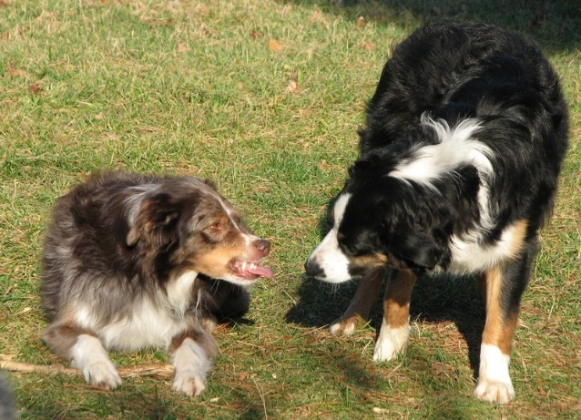
Warning Behaviours
Again, we looked at this in the previous lesson, and in this lesson we will see dog-dog warning behaviours used as communication.
Again, similar to correcting behaviours, warning behaviours are often punished or misinterpreted as bad behaviours, yet the opposite is true. A dog that delivers warning behaviours is a great dog, that is communicating its discomfort, and allowing the source of discomfort to alter their behaviours to avoid conflict.
Dogs need to learn that warning signals mean a potential fearful or painful situation is imminent, so dogs that display warning signals toward puppies play a vital role in that dog’s education. Dogs that are not socialised as pups fail to learn to recognise warning signals resulting in situations where fights can occur.
Warning behaviours were all looked at in the prior lesson, and include hard stare, lip curl, direct eye contact, growl, air snap, and so on.

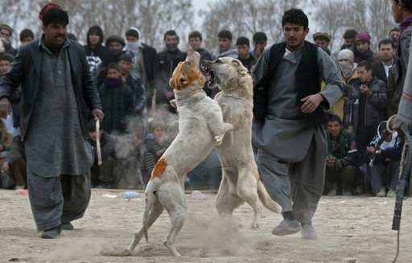
Fight Behaviours
Fights are part of communication. They also establish relationships and resolve conflict in certain situations.
During dog fights there are different levels. A snark is a display of aggression, usually using correction behaviour, from one dog to another. It is loud, and sounds vicious, but usually only lasts about 2-3 seconds. Dogs should be separated and investigate the cause of the snark.
A tiff is similar to a snark, though both dogs are involved, usually when one dog is ‘told off’ and argues back. Usually both dogs ‘listen’ and it is nothing more than handbags at dawn, where the dogs basically ‘shout’ at one another but no physical contact, or minimal contact is made.
A scuffle can break out if both dogs have a tiff and refuse to back down. Usually starts as a snark, becomes a tiff, then a scuffle breaks out as both dogs ‘put their foot down’. Neither dog is injured, if uninterrupted it would usually stop after about 10 seconds, coats can be ruffled and may have slobber on each other. Both dogs need to be isolated for the rest of the day after this as the stress levels will remain excessively high.
A fight lasts more than 10 seconds, often dogs may need to be physically separated, and will both need vet checks as even if external injuries are not evident there may be internal damage. Fight behaviours mimic many play behaviours. Serious fights involve dogs aiming bites at the other dog’s stomach and neck, but also at their legs as they attempt to get the other dog on the ground.
Fights occur for many reasons, and will be explored further in our module on aggression.

Communication at Greetings
Initial greeting forms a basis for the development of any relationship. When we first meet someone, whether we want to or not, we quickly make judgements and assumptions. Early conversational topics such as where are you from, how old are you, where do you work and so on allow us to learn about the other person, and dogs do this through their nose.
Behaviours are offered, and the response from the other dog allows both dogs to determine where the relationship will follow.
Interpreting dog-dog greetings requires you to understand the emotional state and communication of both dogs, and the ability to predict how greetings of two dogs will proceed by the signalling being sent. Of course this is where a sixth sense is helpful, as predicting the future is always slightly tricky!
Often your assumptions will be incorrect, and it is always best to err on the side of caution. Visiting your local park will help, as practice makes perfect!

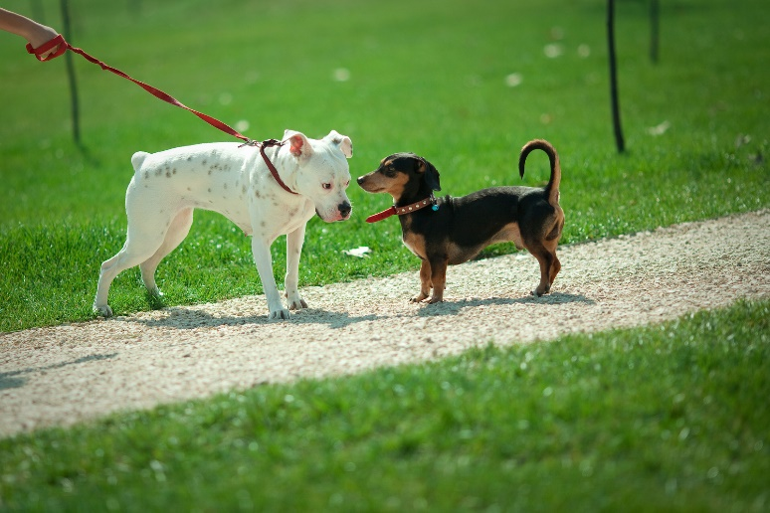
Approach
Dogs that are unsure or do not want to interact will busy themselves elsewhere, perhaps performing displacement behaviours or attempting to move away from the other dog. This should be respected, and the other dog should not approach. If they do approach, then the interaction must be supervised carefully. ‘Mugger’ dogs often investigate the other dog despite the other dog communicating their discomfort, so this should be interrupted if it proceeds.
Ideally both dogs will be willing to approach one another and their behaviour will match one another.
Occasionally a dog displaying appeasement behaviours will lay down while focusing their attention on the other dog to invite them to approach, again this must be observed closely and once the second dog sniffs the dog displaying appeasement behaviours, this appeasing dog should get up and approach the second dog voluntarily.

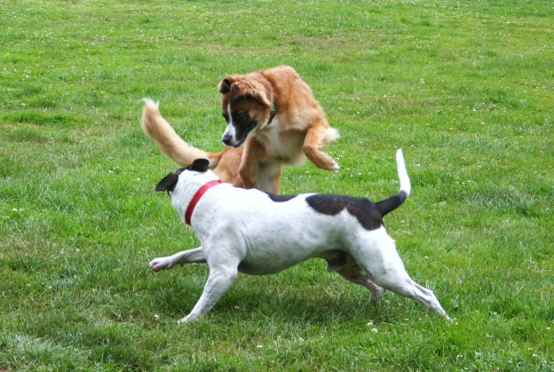
Angle
The dogs should approach one another with a curved angle. Approaching head on can be interpreted as confrontational. The dogs can approach in a semi-circular motion, and with a curved body.

Speed
The dogs approach one another at a moderate speed, interpreting the behaviour of the other dog.
Should the dogs bulldoze toward each other they often fail to read the other dogs body language resulting in potential miscommunication.

Ritual
The greeting ritual involves sniffing the muzzle, neck, then approaching the genital area, and both dogs slowly move in a circulate motion.
This allows both dogs to evaluate the other, which then allows them to determine how the relationship will proceed.
Confident dogs will often engage in the ritual behaviours before deciding to play or go back to what they had been doing.

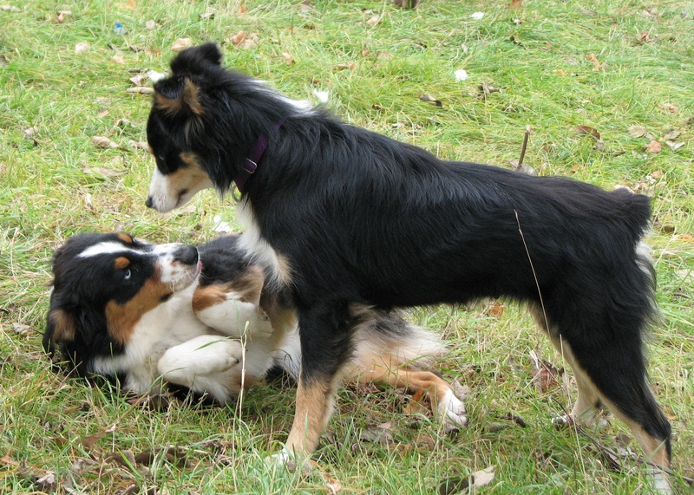
Insecure Dog
An offensively insecure dog will display challenging behaviours. The head and tail will be held high, ears forward, direct stare, very still. They may perform a correction behaviour if the other dog does not show appeasement or submissive behaviours.
If two offensively insecure dogs greet a fight may ensue as both dogs attempt to control one another.
A defensively insecure dog will show appeasement behaviours. It may wait to be approached, or crawl toward the other dog. Two defensively insecure dogs will often quickly begin playing as they recognise that neither poses the other a threat.

Arousal
High arousal in a greeting situation is always grounds for interrupting, or avoiding, a greeting. Threat interpretation is skewed when arousal is high, so this can result in fight behaviours following.
Signs that the dog is highly aroused include very stiff, or tense body language, piloerection, and freezing. If play follows it will be erratic, clumsy and again gives ground for miscommunications.
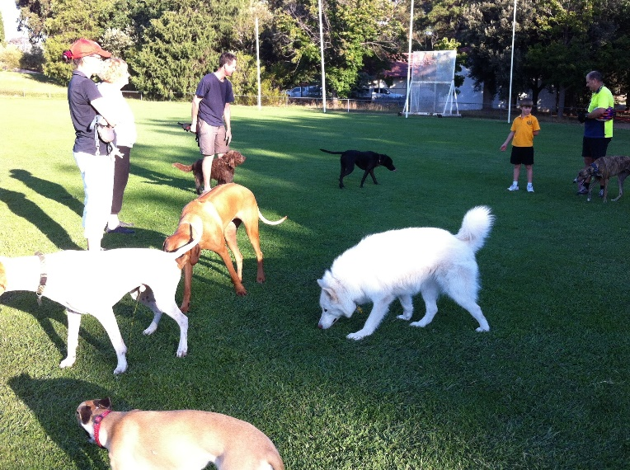
A Note on the Tail
The higher the tail, the more offensive the dog is (willing to move forward and engage).
The faster the vibration of the tail, the more aroused the dog is.
The wider the swing of the tail the happier the dog is.
A rigid tail (often straight out, at its normal carriage height or slightly higher, like it has revived a jolt of electricity) is a dog that needs more information but is highly aroused.

