Practical Dog Management
Unit 6 Communication Skills
Signalling

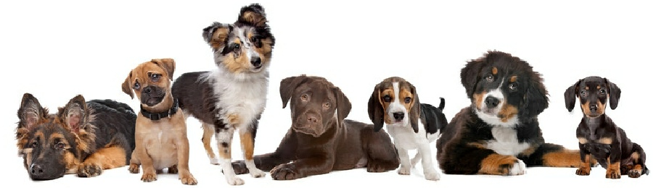

Dog Communication, What Is It?

Animals that live in social groups, communities, or rely on other individuals for survival need to be able to communicate.
Communication can be defined as the sending and receiving of a message which alters the behaviour, or changes the knowledge, of the receiver.

Dog communication can be delivered, interpreted, and categorised in many ways.
Communication can be auditory (barking), olfactory (releasing scent through the body and excretions), tactile (touching with paws, muzzle or body), pheromonal (releasing pheromones received through the Jacobson's organ or the vomero-nasal organ (VNO)) and visual (through body language).

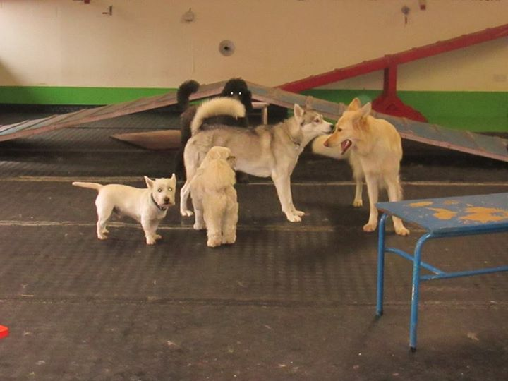
Body language is communication. Dogs use a wide variety of voluntary body postures and facial expressions to communicate their intentions, or emotional state, with the intention to change the behaviour of others in their environments.
Dogs also have involuntary responses to emotional states which can be interpreted by other dogs, and clued in people, to allow further understanding and interpretation of their state.
Like human language, many dogs need to learn how to communicate, and understand the communication of other dogs. Some communication signalling is innate (for example, behaviours seen in blind and deaf dogs) while others require the dog to have the opportunity to interact with many other dogs to develop an understanding of body language.
Puppies learn from their littermates and mother, then a well socialised dog would be exposed to new dogs up to 12 weeks to learn from the other dogs. Continued exposure to other dogs while that pup is developing will allow for further learning of the intent and communication behind signalling.
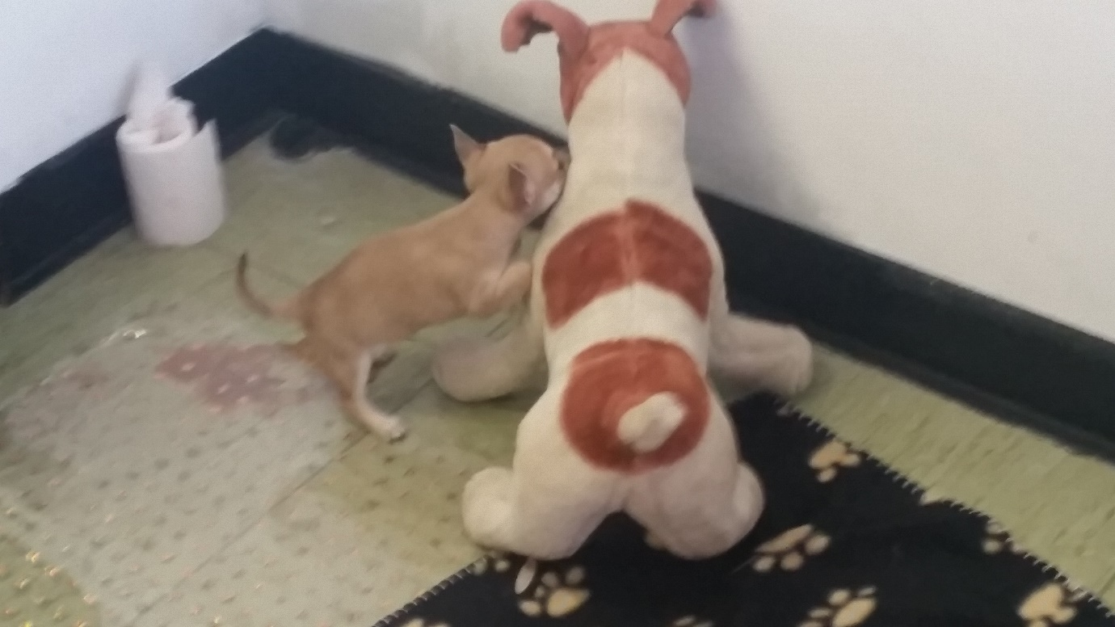

Obstacles to Communication
Some dogs, due to appearance, can deliver messages they do not intend to, or their messages can be missed, or misinterpreted.
The facial expressions of black dogs, or dogs with shaggy coats are often difficult to read.
The natural stance of boxers, great danes and other deep chested dogs can often be interpreted as a challenging stance whereas selective breeding has developed a dog whose neutral stance has the chest thrust forward and head held high.
Dogs with drooping ears such as basset hounds, or cropped ears as can occur with pit bulls cannot use their ears as effectively as they should for communication.
Dogs with docked tails cannot communicate their emotional state with the use of their tail.
Miniature dogs often are misunderstood by larger dogs as their subtle communication can be missed due to their size.
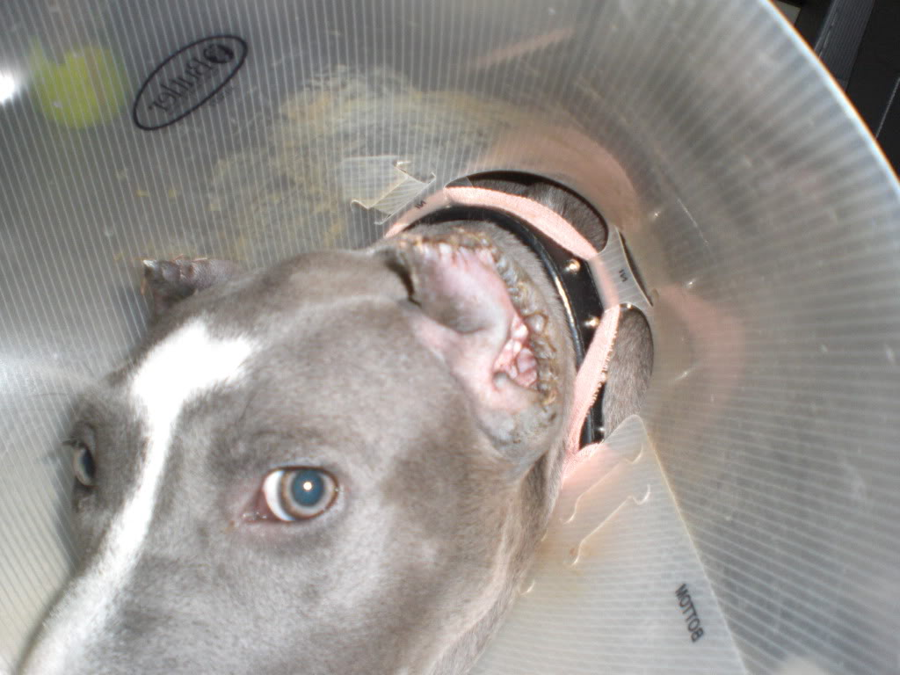
Dogs that only socialise with a certain breed, or type of dog, can often become limited with interacting with other dogs, again as they do not understand them. Dogs that only interact with boxers may accidentally ignore the communication of a challenge from a husky.

Understanding dog communication is vital, as this is how you can become a ‘Dr. Doolittle’, speaking to animals requires little more than the knowledge to correctly interpret their communication, and the ability to respond appropriately.

Communication can be categorised in many different ways.
The below table will give you some ideas of categories, but in reality, understanding the individual signals purpose is the best way to understand the message.

Category | Intent | Behaviours | Jaak Pankcepp Emotional States
Green | Interact with me | Distance decreasing behaviours | Lust  Care  Play
Orange | I need more information | Displacement behaviours | Seeking
Red | Move away | Aggressive Behaviours | Rage
 |  | Appeasement behaviours | Fear
 |  | Involuntary Behaviours | Panic

Interpreting Body Language

Firstly, before we begin discussing what communication means, we need to understand that dogs make liars of us CONSTANTLY.

Many signals that dogs give that show they are uncomfortable are identical to signals they give when they are completely relaxed, and often a still photo will give a snapshot that could be completely misinterpreted so it is important to take many aspects in to consideration when analysing communication.
Look at the surroundings – what just happened, where is the dog, and what has occurred in similar environments in the past?
Look at the complete body – is their face saying one thing and their body another?
Watch and observe – A snapshot will give you one understanding, but watching the dog for several seconds will help you gain a truer picture.
Movement – is the dog moving toward or away from the stimulus to which they are giving communication?

Remember this. Behaviour is fluid. Body language is fluid. Signals can mean multiple things. Practice, practice, practice.

This lesson will create an ethogram for interpreting and translating communication, though remember, it is a snapshot so the explanations for the behaviours below are IN CONTEXT! An ethogram is a catalogue or inventory of behaviours or actions exhibited by an animal used in ethology (studying animal behaviour in its natural environment).
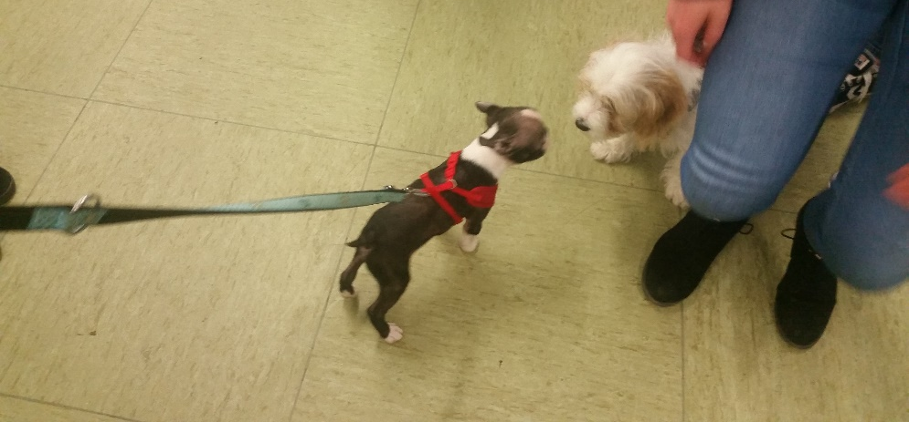
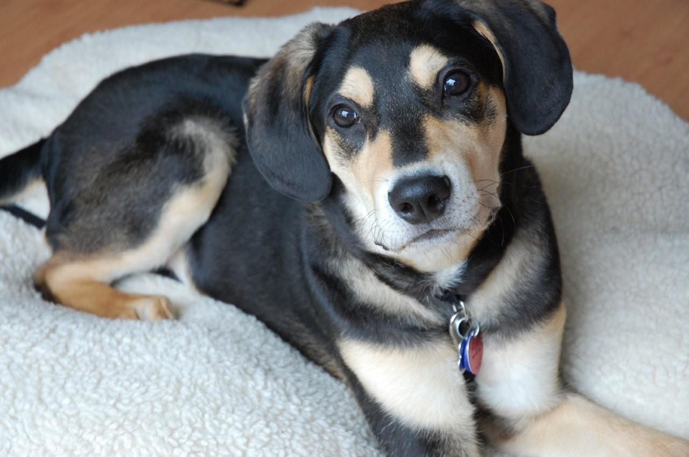
I am Relaxed
Figure 1 Dogs with brown eye brows often look worried due to their markings but if you look closely, no wrinkling around eyes nor any facial tension

A relaxed dog is often passive, so they are communicating very little, which in itself is strong communication.
Imagine a teacher walking into a new classroom, in a relaxed manner, they are communicating that the situation is not phasing them, which is non-threatening to the students, but also teaches them that this teacher won’t take any messing.
Often a dog can be seen to be communicating that it is calm and confident when it is in its own home, pottering about.
Relaxed body language from a dog is rarely misinterpreted.

Eyes
No facial tension in muscles around eyes. Stress ridge between eyes missing. Pupils are not dilated. Dog will either have eyes closed, or will be watching something which is of little interest. Gaze will not shift rapidly.
Ears
The dog’s ears will sit in its natural state. They may be bi-orientated or slightly focused on something of interest.
Face
No facial tension. Head orientated toward whatever is of interest in the room, perhaps watching people move about.
Body Posture
A relaxed dog is sitting or lying in the majority of situations. Or stands before choosing where to settle.
Movement
Any walking is at normal speed, not fast or slow. Dog might be seen circling before lying down or looking for a comfortable place to rest.

I am a Happy Hound
Figure 2 Dog has a cataract (which reflects green in flash images) which allows us to see that pupils are not dilated
A happy dog will show signalling that it wants to interact with the world. Their energy levels, called ‘arousal’ in the dog behaviour field, will be slightly elevated than the relaxed dog, but it is still calm.

A happy dog, in human terms, is not a person at a concert, but instead someone interacting with friends or family that they see regularly, they are wanting to engage and communicate, catch up on any news, but there is no need for hugs or excited chatter!

A happy dog is communicating that they are comfortable, confident in the situation, and seeking interaction. They are not feeling fear, they are not overly aroused, so to another dog, the happy dog should not pose a threat provided the happy dog has manners. A happy dog with manners will display that they would like to interact with another dog or person, but will then listen, and give that individual space is that is what is communicated. A happy dog without manners will go and sniff another dog or invade a person’s personal space despite signalling requesting that they don’t.

People who do not know dogs, and perhaps fear dogs, could misinterpret a happy dog as a threat as the dog seeks to interact.

Eyes will focus on the target of their interaction. It is usually another dog or person, but could be an object to play with.
Ears will be directed toward what they are looking at.
Facial tension is still absent. Mouth is usually hung open.
Body Posture is usually curved, soft movement, tail hung slightly higher than relaxed state. Moving from side to side in an undulating fashion, at a medium speed.
Movement is usually toward the target of their desire, though they will leave it if called away.
I’m Happy but Shy
Appeasement behaviour is a form of social behaviour in which one party seeks to pacify the aggression of another by taking an inferior social stance. This occurs amongst both animals and humans. Shy dogs often interpret threat in non-threatening situations, and approach such situations showing appeasement signals. This is similar to a victim of emotional abuse becoming a pushover in the workplace.
Alternatively, dogs learn through puppyhood that appeasement signals toward other dogs resulted in a desirable outcome and continued to show these behaviours, through learning, later in life. This is similar to, in certain situations, where a woman may act meek and vulnerable to manipulate a man into thinking that she is powerless and he then mows the lawn, washes her car, puts together her new Ikea furniture and more. She has learned that showing vulnerability actually allows her to get what she wants.
Both dogs are often dismissed as ‘submissive’ dogs.

A dog showing appeasement behaviours will be seen doing the following.
Eyes may include eye contact followed immediately by averted gaze, then repeat.
There may be slight furrow in the brow between the eyes.
Lip licking around the muzzle is seen, and if close enough, the dog will attempt to lick the muzzle of the other dog or the mouth of the person.
The ears will be orientated away from the person or other dog.
Body posture will be lowered, and if the dog is approaching they may do so in a lowered body motion similar to a crawl with the head looking upward.
A paw lift is often seen.
Paw lift possibly followed by a tap-out where the dog crawls into a ball and rolls over to expose its stomach. Unlike a belly rub, in a tap-out the tail remains tucked up to cover genital area.
Tail will be tucked (though usually not pinned) to undercarriage, and will be slightly vibrating.
A submissive grin is seen in happy shy dogs occasionally. Often mistaken for a lip curl meaning aggression, the submissive grin sees the dog bring it’s lips back exposing its teeth.
Submissive Urination is sometimes seen, especially in younger dogs with less control of their bladder, or in dogs that may have experienced fear or punishment, meaning their appeasement signals are in response to a past ‘real’ threat, resulting in the dog to panic slightly more.

Curved Bodies are seen, where the animal attempts to remain non-threatening.
Happy, shy dogs may engage in tactile communication where they use a paw to touch, or a muzzle nudge to make physical contact.
They often curl close to the person or dog that they are focusing their attention on.

Often with a happy, shy dog, these appeasement behaviours are shown during greeting until they determine that the other dog is not a threat then play can pursue.

Appeasement signals are far too often misinterpreted with a dog that is ‘guilty’ or ‘sorry’ which is not the case. The dog is simply trying to remove a potential threat to their survival.

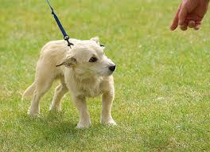

I Am Excited
As a dog becomes more excited and their arousal increases, perhaps during play, the start of a walk, or when they are reunited with a family member, their emotional state causes a physiological response. This is where involuntary changes occur.
An excited dog is still loving life, but as their arousal continues to increase, they become less in control of their behaviours.
Positive stress is called Eustress. It can give an extra burst of adrenaline to help you accomplish goals and meet deadlines. Eustress provides mental alertness, motivation, and efficiency. Eustress can increase self-esteem. If stress levels continue to increase the animal enters a distress (panic) state.
An excited dog will look to interact and engage in activities, their movement will be fast, they will be hyper vigilant, and easily motivated to react. If the dog continues to increase in its arousal level, there is a risk that the dog may become less conscious of its surroundings, including less able to interpret threats, and fights can occur if the animal continues on this path.
In human terms, a dog in their excited state is similar to a teenage pop fan attending a concert for the first time. As they arrive at the venue, their arousal levels increase, and the closer to the start of the concert, the higher their arousal, and stress levels. While in the eustress state the fan is able to engage in conversation, focus on their surroundings, and has good control of their motor skills. Once the pop band come on stage, the fan enters a distress state, so they are unable to properly focus, may cry, scream, stumble around and so on.
Another example would be rock fans in a mosh pit. Eustress is when they are having fun, singing along, distress when they become too aroused and fights break out.

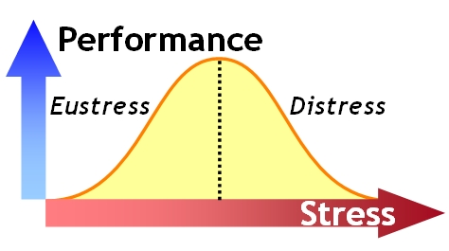
When happy and excited many dog’s intentions are to get a reaction from another dog or person, or to engage in activities, exploring, and playing. An excited dog can be misinterpreted as a scary threat as their behaviour is high energy which can be perceived as a threatening baby.

Eyes of an excited dogs are usually moving in focus as the dog is scanning their surroundings, or watching for activity. As the dogs stress levels increase, pupil dilation occurs, and this can inform you that the dog is becoming too excited and needs a break. The whites of the dog’s eyes may become visible when the animal is entering a distress state.
Ears of an excited dog are usually orientated toward what they are interacting with, then can become very active as they become hyperaware and attempt to take in information from all their surroundings.

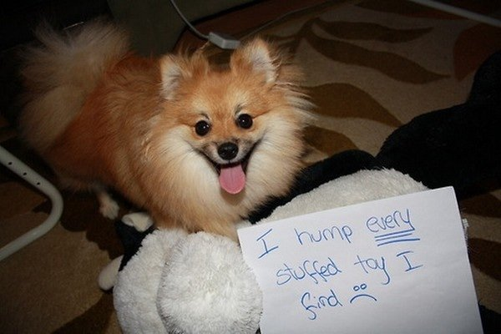
Facial tension will begin to be seen, and as the dog becomes more aroused the facial tension will become more evident.

Body Posture moves a lot in an excited dog. Initially it will be bouncy, fluid and smooth (like a Mexican wave) though as the dog enters a state if distress the body movements will become more jerky.

Involuntary responses to increased arousal and stress levels include the following.
Piloerection – the dog’s hair between their shoulders and along their spine will stand up as a response to the body entering a fight or flight state.
Pupil dilation – of course involuntary, a response to potential fight or flight state to help the animal survive, but in an excited state this is a sign that their excitement levels are entering an increased risk level.

Frantic behaviour is often dismissed as just a play state, though in reality it is showing you again that they are entering a higher risk state.
The dog will be unable to focus, perhaps won’t take food, and will be seen panting excessively as her respiration rate increase.
Zoomies, seen on YouTube and common in puppies, where the dog is running around their surroundings as fast as they possibly can. Often dismissed as an acceptable behaviour, this is a clear sign that the animals internal stress levels are extremely elevated.
The dog may be observed barking in a rapid, sharp yapping manner.
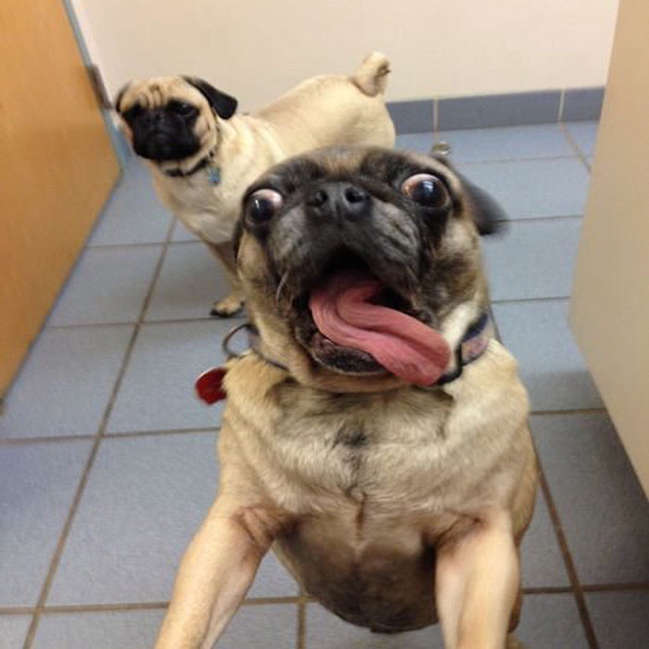
Another sign that the animal was entering a distress state, and their body was entering the fight or flight state, is when you see a dog doing a ‘shake off’. A shake off is the dog attempting to leave the fight or flight state. When a dog is observed doing a shake off, if the reason for the arousal (for example playing with another dog) does not stop after the shake off, then the dog should be taken out of the environment.
While this dog is enjoying itself, its arousal levels must be carefully monitored and the play or activity must be interrupted if arousal levels begin entering a distress state.

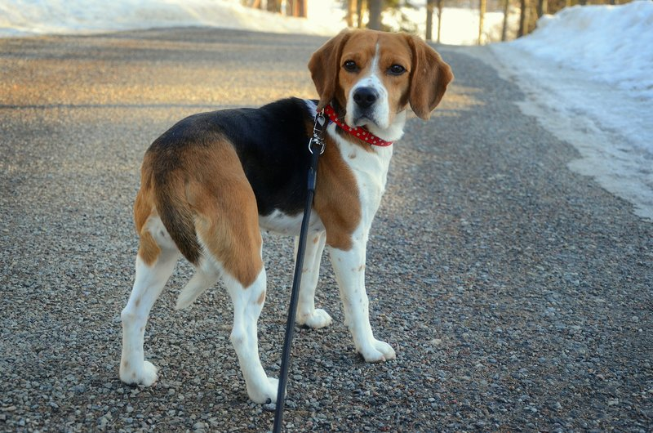
I Need More Information
When a dog is exposed to something new, depending on that dog’s individual history, personality and the situation, the dog may need time to gather more information. This dog does not yet feel threatened, but needs time to determine if there is a threat, if they are safe, if there is something to hunt, if there is a reason for play, and more. As above, they simply need time to gather more information.

Communication Intended, especially toward another dog, is that they need space and time to decide their response.
Misinterpreted as a happy dog, as they are not showing signs of aggression, and often dogs that need more information are forced into situations before they are ready. This can result in an aggressive response, or a dog developing a fear where they would not have if given time.

In Human Terms the dog that needs more information is similar to a child visiting relatives that they are not familiar with, and the child stands back behind their parent until they have determined the environment and gained confidence to interact. Pushing that child to go and hug the unknown relative could cause the child to develop shyness, or social anxiety.
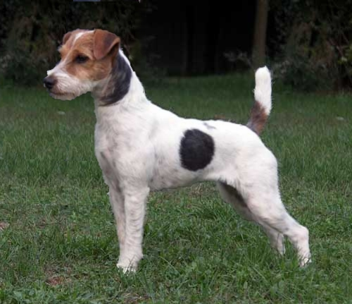
Eyes are focused on the stimulus that they are unsure of. Pupils are not excessively dilated, but some facial tension may be seen around the eyes. Whites of the eyes are not yet seen as the dog is not distressed or afraid yet, just learning.

Ears are orientated toward the stimulus they need information from.

Face only has some facial tension, and the head is somewhat high. The dog may be seen sniffing the air to gather more information. The mouth is closed. The head may be angled to the side as they are listening.
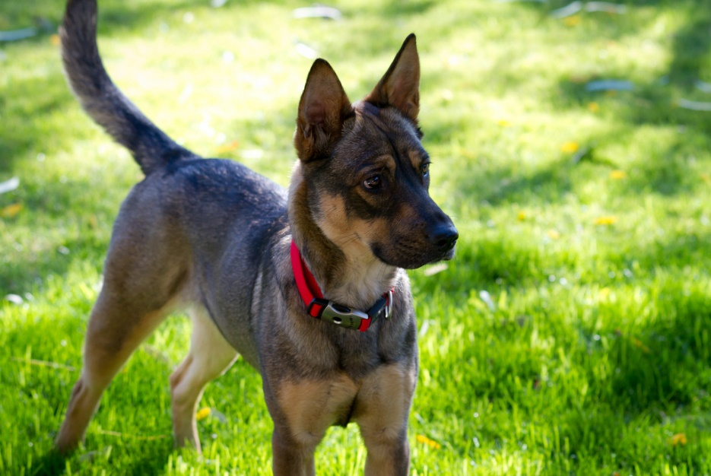
Body Posture is tall and still, paw lift may be seen where the dog lifts one paw.
Movement is absent as the dog stays still, but the head may be moving so that the dog can watch, and sniff the air.
Tail is rigid, can be straight out with no curve.

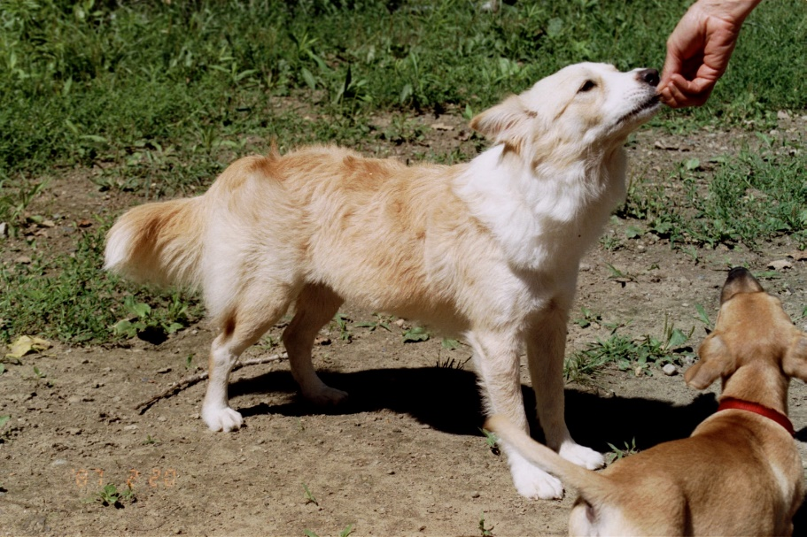
I Am Unsure
An unsure dog is similar to a dog that needs more information, but this dog is assuming that the new stimulus is a threat. The dog who is unsure is likely to display appeasement behaviours.
Appeasement behaviour is a form of social behaviour in which one party seeks to pacify the aggression of another by taking an inferior social stance. This occurs amongst both animals and humans.
Appeasement behaviours are often misinterpreted as a dog that is a submissive dog, and will always submit to other people or dogs. Many people want to see appeasement behaviours in their dog, as they assume that this means their dog would never pose a threat or display aggressive behaviours, whereas appeasement behaviours in most simulations show that the dog is not completely comfortable, meaning that there is an increased risk of a bite should the dog be pushed.

Communication Intended by an unsure dog is intended to tell others that this dog does not pose a threat, hence, please don’t hurt them. The dog is afraid, and wants to actively reduce the threat so that they don’t get hurt.
In Human Terms the unsure dog is similar to the person who walks into the post office, hears shouting, and waits at the entrance for a moment. Should 5 customers bundle out of the post office and rush past the person before they have had the time to take in information, they are likely to also turn and flee, and potentially fear returning to that post office.

The behaviours will be similar to the happy but shy dog, though the ‘happy’ side is absent.
Eyes may be angled away from the stimulus. They may look when they believe the stimulus is not focused on the dog, but should the ‘threat’ look at the dog, they are likely to look away. The dog wants to continue to monitor the potential threat while also scanning to look for routes of escape, or other potential threats.
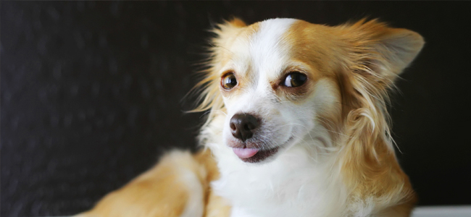
If the potential threat is an object, such as a new piece of furniture, the dog will continue to focus on the object.
Avoidance, such as a head turn (turning the head away) or moving away is likely to happen.
Ears are usually orientated away from the stimulus that is the cause of the unsure emotions, as the animal is trying to gather information on escape routes.
The mouth is closed, again as the dog needs to gather information. Some facial tension may be seen.
Again, depending on the type of stimulus that is causing the dog to feel unsure, their body posture can alter. If it is an object, the dog often slowly leans toward the object to explore, whereas if it is a moving object the dog is likely to make itself as small as possible, crouching or curling into a ball so as to hide from the potential threat while trying to gather more information. If a hiding place is available, they may hide until they feel more confident.
The dog’s movement is hesitant. They often approach and move back quickly as they are both inquisitive and nervous.
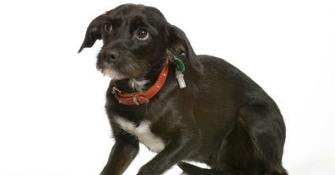
Should the dog be with another person or dog that they trust they are likely to be seen carrying out a ‘check in’ where they look to gather information from the other individual’s emotional state.
Should the dog decide to approach, whether it is another person or animal, they may approach showing a submissive grin. This looks like a lip curl, as the dog raises its top lip to show its teeth.
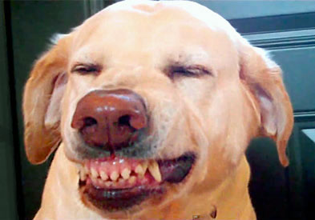
A submissive grin is seen with the ears pinned back. A dog may stay where it is and show a submissive grin or may approach grinning. Should the dog remain where it is, it should not be approached, but instead wait for that dog to approach you.
Submissive Urination occurs when the dog is unsure. Often seen in dogs that had been mistreated, or fears this person will mistreat them. The submissive urination allows the ‘threat’ gather information from the dog, usually that they are not a threat, without having to actually approach the unsure dog closely.
Excessive Blinking
This is seen when the dog wants to break contact and appease a threat. This is easy to miss unless you are looking for it, the dog makes eye contact with the threat then blinks excessively to show that they are not a threat.
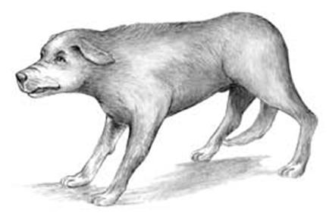
Squinting
Squinting is similar to excessive blinking, the dog again looks toward the threat but half closes its eyes, again to show that it is not a threat.
Tail
Lowered but still wagging in a narrow swing at high speed.

Displacement Behaviours
Displacement behaviour is usually thought of as self-grooming, touching, or scratching, which is displayed when an animal has a conflict between two drives, such as the desire to approach an object, while at the same time being fearful of that object.
If the dog is motivated to approach, but also afraid, they are likely to show displacement behaviours.
It can be seen in an unsure dog, or an uncomfortable dog, and the outcome is always the same, give the dog more space and allow them to gather more information.
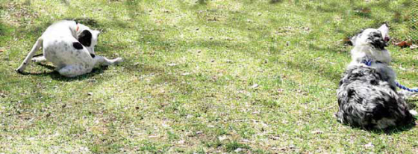

Scratching
The dog is seen scratching when they should not be itchy. Normally scratching is carried out with the back legs around the collar or back. The dog focuses intensely on scratching.
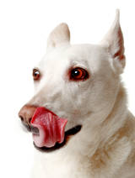
Lip Licking
Lip licking is often seen as a displacement behaviour when the dog is breaking the tension, the dog will rapidly lick its nose, or will do a wider lip lick where it licks the top lip from one side to another. Often followed by a yawn.

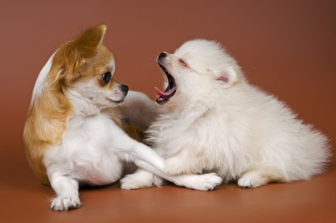
Yawning
The dog yawns like it would if it was tired, though a stretch is absent and if you watch closely the dog does not appear to take in much air.
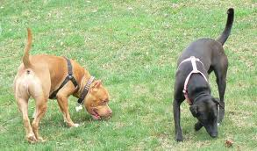
Floor Sniffing
This occurs when a stressful event happens and the dog attempts to distract themselves. Again, often missed unless you know what you are looking for, but it is a subtle sign that the dog is uncomfortable and unsure about the best way to respond. They are of course dismissed as being relaxed, but you are expected to know better with your education.
Urogenital Check In
The dog suddenly becomes extremely interested in checking in on its genital area to distract itself from the environment, and to show the environment that it is calm and not a threat. The dog is taking a moment to gather its thoughts before it’s next action. Again, give this dog space.

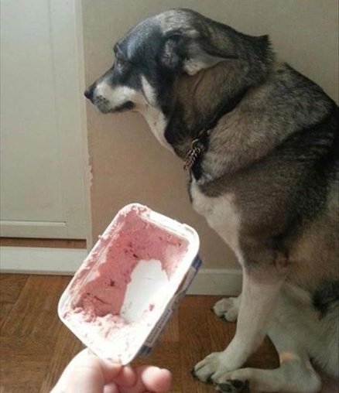
I am Uncomfortable
An unsure dog that has determined that the stimulus is a threat is going to show
Often misinterpreted as a ‘guilty’ dog, or a ‘sorry’ dog whereas it is instead faced with a threat and is trying to have the threat dissipate.
Many signals are intended communicate to the other individual that the dog sending the signal is afraid, and is showing that they are weak so that the other dog or person doesn’t challenge the dog.
In human terms, these behaviours are a child saying to a bully “please take my lunch money just don’t hurt me”

Communication is intended to have the other individual walk away and leave them alone.
Eyes
May be blinking and squinting, but also, when the threat looks at the dog, they will avert eye contact.
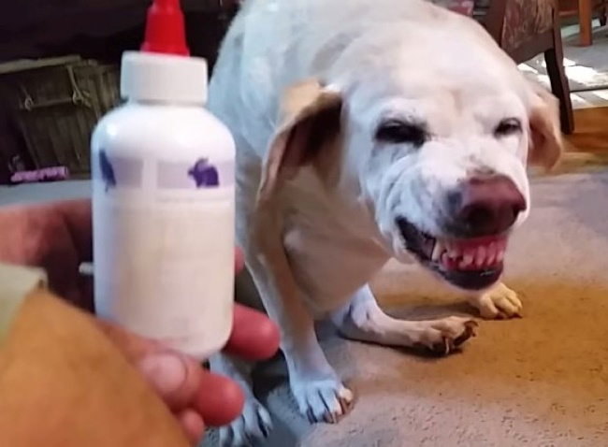
Ears
The dog’s ears are orientated back to look for an escape, pinned back and flat against back of the head, to protect from injury if they believe they will be attacked.
Face
Tension around the dog’s eyes and cheeks are visible. Ridges on the forehead can be seen. Facial tension can bring skin back from eyes causing the whites of the eyes to be visible, called ‘moon crested’ eyes.
The dog will do head turns and orientate away from the threat.
Body Posture
The dog is seen crouching, sitting in a ball, or carrying out a tap-out where it is showing its stomach but has its tail tucked against its genital area.
Movement
The dog is avoiding the threat, so attempts to move away.
Tail Tucked under the stomach, or else lowered from its normal carriage. It may be vibrating if it is attempting to appease the threat.
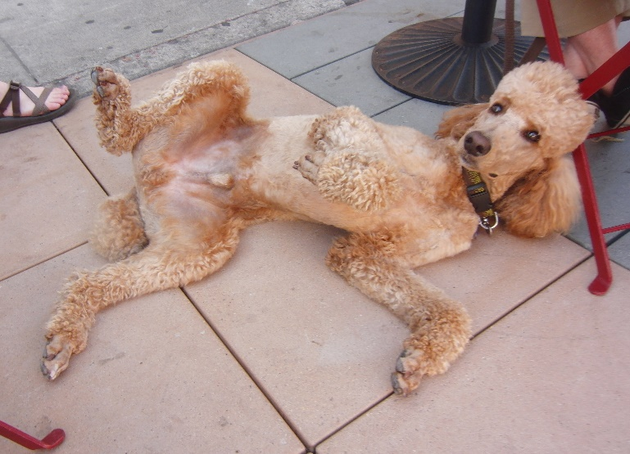
May be slightly vibrating under the dog’s carriage.
If the dog is approached too closely, and its personal space is invaded, then space requesting licking can be seen, often dismissed as a happy dog. The dog tries to avoid interaction, and when this is not listened to the dog will lick the face of the ‘space invader’ to attempt to get space without having to use aggression. Often seen when children hug dogs.

I am Afraid
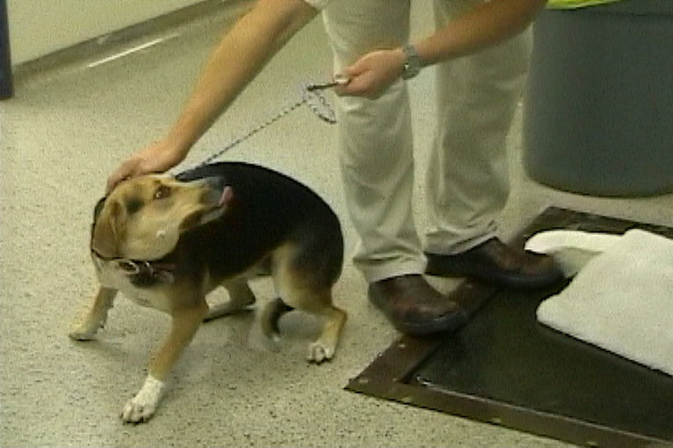
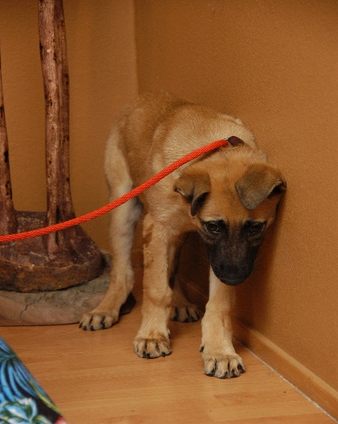
Communication intended to show the threat that the dog will not be responding to them, and that the dog is choosing to escape. Fear based communication is often simply done in an attempt to escape, but when working with dogs you need to recognise these signs, and understand that the dog needs space, and provide it.

Misinterpreted as submissive or non-threatening which results in many dog owners failing to react and protect their fearful dog.

In Human Terms an afraid dog is a child in a room full of spiders when that child is afraid of spiders. We wouldn’t be ‘happy’ to see the fearful behaviours in the child in this situation so the same should go for fearful dogs.

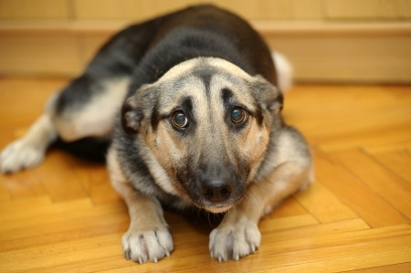
Eyes
Avoidance of eye contact, along with moon crested eyes are often seen. Brows between eyes will be furrowed.
Ears
The dog’s ears will be orientated away, or pinned flat.

Face
The dog will be turning its head away from the threat.
Body Posture
The dog will crouch, or attempt to escape. The head will be carried low, and the rump tucked or lowered.
Movement
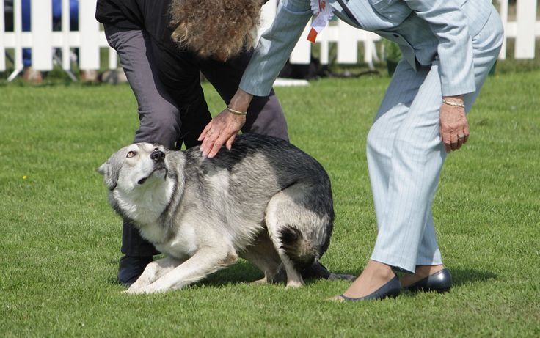
The dog may be seen pacing as it looks to escape in a fast paced manner, move really slowly in an attempt to avoid gaining attention, it may freeze so that it is ‘invisible’.
Tail Pinned
The tail will be pinned below the undercarriage, covering its genital area.

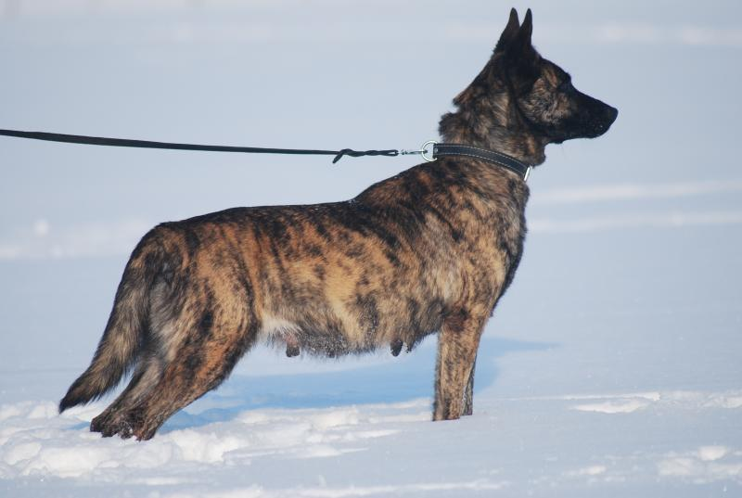
I Am Aroused and ‘In Control’
When a dog is in a new situation, and is alert and wants to quickly establish the relationship, but does not know who the interaction will go, you will often see heightened arousal, you may even feel the tension, and this situation should be interrupted or very carefully managed.
This dog is interested and confident, but is unsure as to how the interaction will go. It is communicating to the other that they should respond appropriately, allow the dog time to ‘figure them out’ and remain still so that the dog can investigate.
In human terms, this is George Bush meeting Barack Obama, where he is feeling like “Hey, I’m the big boy around here bucko”. George marches into the room, making a stern bee line for Barrack Obama, and gives an extra hard hand shake, holds his shoulders high, and makes direct eye contact in an attempt to quickly establish the control in the satiation.
This dog is more comfortable when in control of situations. Often misinterpreted as a dominant dog, but in fact the dominant dog is Barack Obama, who greets George Bush with a friendly smile, saunters into the room with swagger, says hello to the others in the room, and greets George with an informal “How’s it going bud”. He is not threatened by the situation.
Mistaking these aroused dogs as dominant dogs can often be detrimental as if you dismiss this dog as dominant and confident you are failing to see that this dog is actually extremely insecure, which is why they are trying to control the environment to avoid the risk of anything frightening happening.

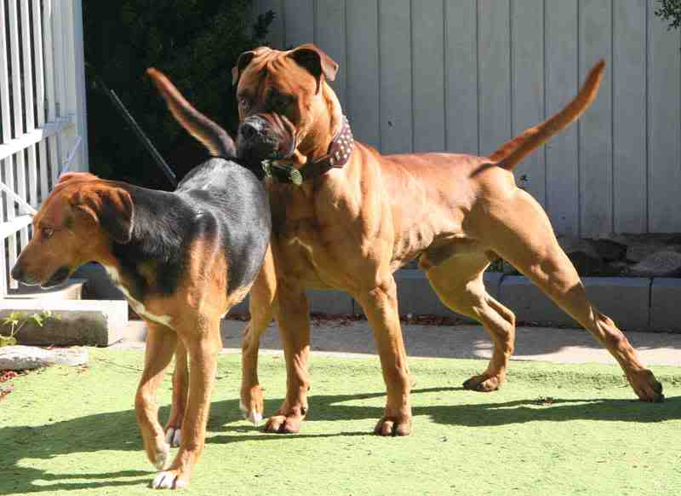
High Tail
The dogs tail of a confident, aroused, but on edge dog will be high, potentially rattling at the tip of the tail, though the lower tail will remain still and stiff.
Still Body
The dog will be using its senses to interpret the situation, so the body is normally very still and rigid. The chest of this dog is thrust forward, head high, and it is attempting to appear as big as possible.
Slow Movement
The dog will slowly move, invading the space of the other dog, sniffing and sticking it’s nose into the other dog.
Piloerection
The hair will stand, especially as tension escalates, so you ideally want to interrupt prior to the piloerection developing.
Sweaty Paws
As the arousal heightens you may notice sweaty paws, especially on floor surfaces that will show the footprints.
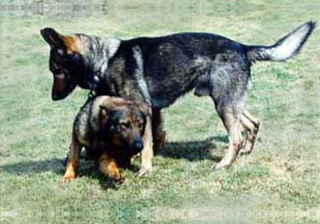
Chin Over
A chin over is a very challenging behaviour that can lead to a fight in many situations if the other dog will not tolerate being ‘pushed around’. The dog places its head high and over the other dog, usually over their shoulder area. This dog should be put on a time out immediately.
Controlling Other Dogs Movement
The dog will attempt to herd, or interrupt the other dogs behaviours as this will help them control their environment. The dog may get in the way or the direction of movement of the other dog (or person), may yap at them, or nudge them to get them to move and so on.
Mounting
Mounting is a very controlling behaviour where the dog is attempting to overpower the other dog or person. It is of course seen in a sexual nature though in play or dog dog greetings it is often used to control the other dog. It should always be interrupted as in many cases the other dog will not tolerate it and a fight could follow.

Paw Over
The dog, especially breeds like boxers, play by jumping and putting a paw, or two paws, over the other dog’s shoulder. Later in play this is acceptable in many interactions, but if seen in the initial stages of building a relationship, it can be a very threatening behaviour.

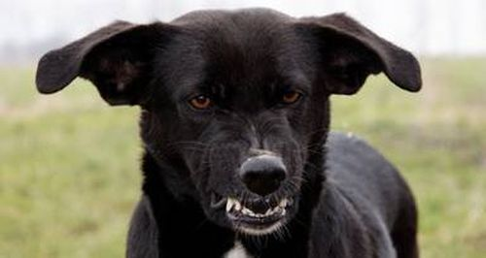
I am Warning You
If the dog sees a potential threat, they will begin communicating the message that they may have to use physical force if the other person or animal does not listen or comply to their instructions.
The dog is uncomfortable and unhappy with the way the interaction has been going, and needs to warn the other to back off.

This is the person in your office that has had enough and turns to their boss, hands folded, cross face, and says “If you give me ONE more file to work on, I will storm out of here and never come back”.

Misinterpreted as dominance, whereas the dog is communicating they are not happy, and warning that aggression may follow, which is actually a great thing, as they haven’t gone straight to bite – or the lady in the office has not resigned, she has given her boss a chance to straighten up.

There are usually two types of warnings, offensive or defensive. The offensive dog is saying ‘I’m a gonna bite ya’ whereas the defensive dog is saying ‘Please back off, I really don’t want to have to bite’.
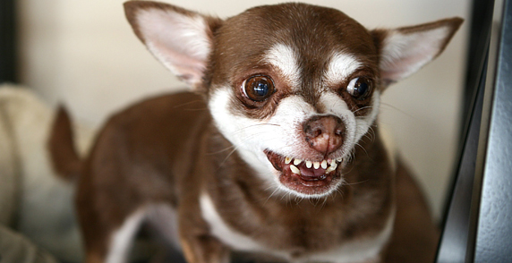
Eyes
The eyes will focus directly on the individual that they are warning. If they are offensive and coming from a rage emotional state you will see a hard stare, it is direct eye contact, pupils may be dilating, and the dog will hold the eye contact. The skin around the eyes will be hard, the eyes will be held open wide, but the frown and tension around the eyes will usually stop the whites of the eyes from showing.
If the dog is defensive and coming from a fearful state you will probably see a head turn, where the dog focus their head away from the individual, but keeps the eye contact on the individual, causing the whites of the eyes to show in the corners.
A dog can flick from offensive to defensive and back again, it can continue to alter between the two messages.
Ears will be pinned back in a defensive dog, but forward and directed at the individual in the offensive dog.
Body Posture will be upright, weight forward, with head low but straight forward in an offensive dog but curved, weight shifted backward, head angled upright and again curved in a defensive dog.
The defensive dog may still be seen offering appeasement signals mixed with threat signals.
Movement in both dogs is likely to be absent, they are likely to be very still, the offensive dog potentially creeping forward while the defensive dog will stand its ground while attempting to appear small.
If you, or the other dog, moves forward, the offensive dog may pounce forward.
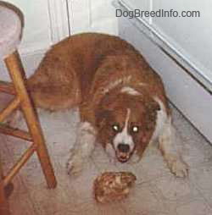
A lip curl will be seen, where the dog shows its teeth. Difficult to see in dogs like great danes with extra skin around the muzzle. A defensive dog will pull the skin right back, showing the back teeth, and the offensive dog will have the lips pursed forward more similar to a kiss.
Both dogs can be heard growling, usually starting off low then escalating as the threat does not reduce. A bark can be seen, usually a rapid fire yap, yap, yap, like a machine gun.
The dog will often freeze momentarily. The dog will hold its breath for a moment, remain statue still, but may then ‘explode’ after freezing.
As the tension and arousal builds, a lunge forward may be seen as the dog can no longer tolerate the arousal or threat. The barking is also usually seen with the lunge.
An air snap can be delivered as a final warning before a real bite, the dog knows where the threat is physically positioned, so ‘bites’ the air near the individual.
A muzzle punch is a conscious aggressive behaviour. People can dismiss it as an accident, or a bite. The dog keeps its mouth closed, or air snaps / barks as lunging forward but keeps its mouth closed as it makes contact.
Muzzle Punch
Can be a challenge to push the other animal into a reaction.
I am in Distress
We covered some of the behaviours and signs that the animal is in a highly aroused state. It is important to remember the difference between eustress – increased arousal while the dog is in control of itself, and distress – where the animal is in a panic state.

The categories we are all familiar with are fight or flight. This is said when the animal is in a distress state, and the body is entering the sympathetic nervous system. Lesser known is freeze, frenzy or flirt. They are pretty much self-explanatory.

Flight
The animal will pace, attempt to find a route of escape, perhaps scratching at doorways, or seen struggling to escape from a leash and collar while pulling away from the cause of the distress.
A dog in flight distress will bolt if it does get to escape, and will only stop running when the adrenaline begins to dissipate.

Fight
The dog will lunge forward, and carry out some of the behaviours from the ‘warnings’ above, though the dog in distress in fight mode will do all it can to get to the source of their distress to attack it. Often seen in a cornered or trapped animal that is approached and cannot escape as most dogs will attempt to flight instead of fight as it is better for survival.

Freeze
The animal that is panicking will freeze in the hopes that it will be ignored, or the threat will lose interest and move away. This is similar to a rabbit in the headlights, or the dog will very slowly creep away from the threat.

Frenzied
The panicking dog will carry out behaviours without goal, purpose or function, they simply carry out ‘silly’ behaviours as they do not know how to react in this situation. This is the person on a damaged plane running up and down the aisle shouting ‘we’re all going to die’.

Flirt
This dog, as learned as a pup, will respond to panic situations but acting goofy and puppy like, showing submissive behaviours in an attempt to get out of the panic inducing situation.

Physiological Changes
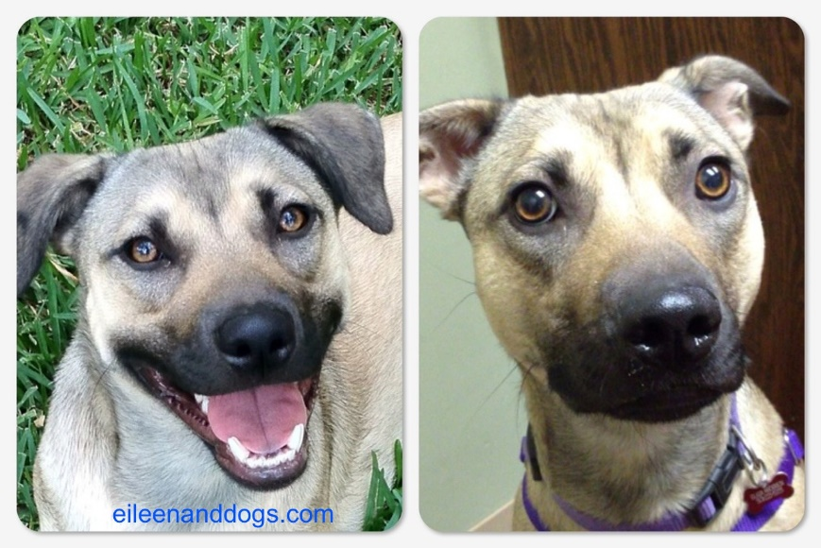
As covered earlier, physiological changes seen in a panicking dog include

Pupil dilation
Easier to see in dogs with paler coloured eyes.

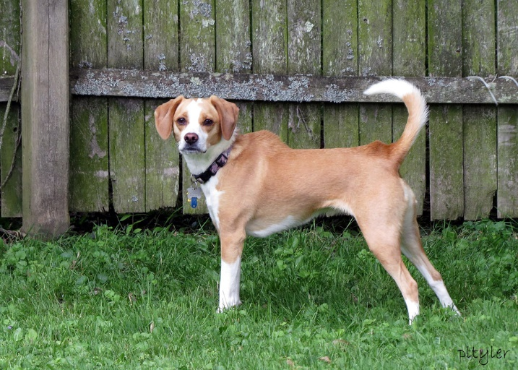
Piloerection
Not an ‘angry’ dog

Sweaty Paws
Only noticed if floor surface allows or you are aware to check for it.

Increased Respiration Rate (Panting)
Panting is dry and laboured

Hypervigilance
The dog’s senses are heightened and it is attempting to take in all information that it can gather.

Urination / Defecation
The dog’s prefrontal cortex no longer controls elimination.

Drooling
As the dog is panicking, drooling increases (in context). In many dogs that remain still, the only sign that they are panicking is the increased drooling.

Rapid Shedding
Very difficult to see, though you might notice in the veterinary practice.

Unconscious Whining
The dog appears unable to stop the whining, like a child in tears that cannot control it.

Shake Off / Half Shake Off
To attempt to decrease arousal, the shake off will help to reduce adrenaline. The dog may do this unsuccessfully if the threat is not moving away, or will do so after the threat or stress has decreased.

In Closing

Going forward, it is important that you review this course many times to continue to ensure all dog communication is forefront in your thoughts.
As you interact with dogs in a professional and nonprofessional context continue to interpret their communication to ensure that you are responding appropriately to keep the dog content.
Step in when you see inappropriate interactions occurring and continue to priorities the welfare of dogs in your care.
Dogs do not have a voice, and many people are deaf to dog communication, so it is your job to step in and be their voice.
